Semi-Autonomous Palm Pruner

Senior Design Final Report – April 9, 2012

*By*

Bill Carpenter2, Christopher Xavier Smith1, Juan Rojas2,

Obie Abakporo1, Sarah Traynor2 & William Craig1

*1Department of Mechanical Engineering*

*2Department of Industrial Engineering*

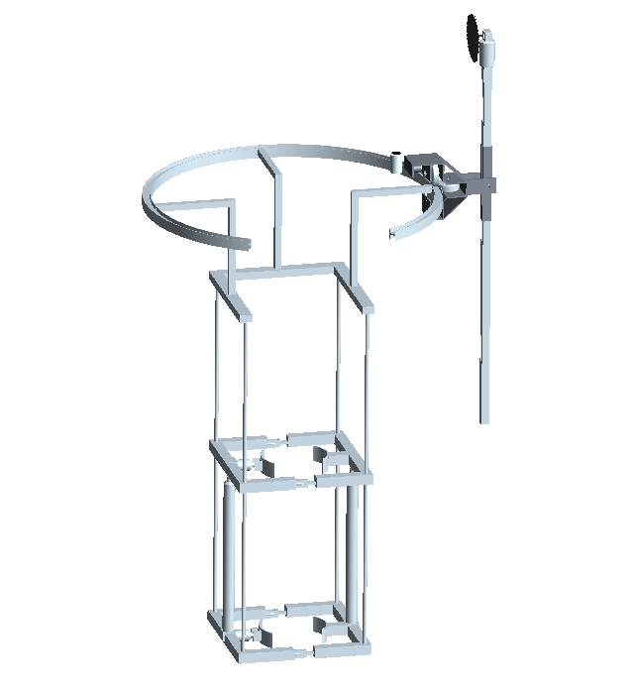

*Project Sponsor*

Dr. Okenwa Okoli, *Associate Professor*

Department of Industrial Engineering



Department of Mechanical Engineering

FAMU-FSU College of Engineering

2525 Pottsdamer St, Tallahassee, FL 32310

**Table of Contents**

Abstract 5

Introduction 6

Needs Assessment 9

Problem Statement 9

List of Objectives 9

Justification and Background 10

Constraints 11

Functional Diagram 13

Quality Function Deployment 14

Project Plan 18

Gantt Chart 18

Engineering Analysis of Concept Designs 19

Concept 1: King Climber 20

Results of Analysis of Design: 24

Concept 2: Rolling Thunder 33

Results of Analysis of Design 35

Evaluation of Combined Results 40

King Climber Product Design 43

King Climber Interactions 46

Human Interaction 46

King Climber’s Response to Human Command 48

Tool Selection 50

Parts and Assembly Process Chart 50

Pilot Testing 52

Engineering Economics 53

Human Labor Aspect 55

Breaking Even 56

Results and Discussion 59

Environmental Impact 66

Health and Safety 66

Ethical Considerations 68

Conclusion 70

Acknowledgements 71

Appendix and Engineering Drawings 72

References 88

Biographical Sketches 89

**Table of Figures**

Figure 1: Functional Diagram13

Figure 2: House Of Quality 14

Figure 3: Venn Diagram15

Figure 4: Pugh Selection Matrix16

Figure 5: Traditional Selection Matrix17

Figure 6: Gantt Chart18

Figure 7: Pro-E Model for King Climber 20

Figure 8: Finite Element Analysis on the lower actuator frame22

Figure 9: Finite Element Analysis of Lower Frame23

Figure 10: Finite Element Analysis on the manipulator track 24

Figure 11: Frame Cross Section25

Figure 12: King Climber Free Body Diagram 28

Figure 13: Pro-E for Rolling Thunder33

Figure 14: Rolling Thunder Top View 34

Figure 15: Rolling Thunder Side View34

Figure 16: Free Body Diagram of Rolling Thunder Design38

Figure 17: Free Body Diagram Showing Torque Interaction38

Figure 18: Pro-E Model for King Climber44

Figure 19: Cutting Arm Concept45

Figure 20: Present/Future Flow Chart54

Figure 21: Present/Future Flow Chart56

Figure 22: Break Even for Palm Farms Purchase of Machine57

Figure 23: Break Even for Selling Machine58

Figure 24: Wiring Schematic 59

Figure 25: Group working on the wiring.60

Figure 26: Testing the actuator with the power supply 61

Figure 27: Constructed frame62

**Table of Tables**

Table 1: Material Lengths Required 26

Table 2: Actuator Selection27

Table 3: Individual Weights 27

Table 4: Summary of Concept #1 Design32

Table 5: Material Lengths 36

Table 6: Material Weights 36

Table 7: Summary of Concept #2 Design40

Table 8: Parts and Assembly Process50

Table 9: Summary of Process Times55

Table 10: Assembly Table and Testing64

# Abstract

Oil palm trees are grown on farms and plantations in subtropical regions around the world. The optimal plant density for these farms is about 58 trees per acre, placed in a triangular pattern approximately 30 feet apart. On average, each acre of oil palm trees produces about 10,000 lbs of palm oil. This is a great statistic of production rate making this market very profitable. Methods to harvest medium sized oil palms have been developed, but there is still a constraint that harvesters deal with in harvesting 40-60 ft. tall palms, this is where our product for an oil palm harvester can be better appreciated and acknowledged.

3E Engineering is dedicated to creating Effective, Efficient, and Economical solutions to global problems. The team is comprised of six senior engineering students committed to solving the problem posed to us by the Industrial Engineering department. Over the past ten years the human labor force in the southern hemisphere for harvesting oil palm fruits has declined. That has caused a great need for more efficient harvesting methods to collect the oil palm fruits to maximize palm oil production. 3E Engineering will develop a mechanized climbing robot to harvest the oil palms semi autonomously and solve the labor deficiency. Our oil palm harvester will also provide additional long lasting jobs as opposed to when harvesters use climbing techniques to harvest oil palms, which can result in injuries, even death. Jobs will last longer because injuries will decrease in the long run and the need of human assistance to move the harvester from palm to palm still remains. Depending on the extent of the oil palm farm that is being worked on, farm managers (with counsel from 3E) have to determine the necessary amount of oil palm harvester operators to maintain a high productivity of palm oil.

We call our design the King Climber. This machine will successfully ascend a tree, harvest the oil palm fruit, and descend a tree with the minimal risk of the operator. This machine will strengthen the oil palm market, satisfy the individual consumer, and decrease the physical labor associated with retrieving the fruit, consequently dramatically decreasing the fatalities and injuries in the field of oil palm harvesting.

# Introduction

The oil palm is developing as one of the major products in the food and cleaning industry because of the palm oil extracted from its fruit. Overall, oil palms cover 27 million acres of productive farmland worldwide. This accounts for 42 countries that have incorporated oil palm harvesting as sources of income. Since palm oil has a high oxidative stability, high level of natural antioxidants, and taking into account the rising price, we can deduct that palm oil is a product in high demand. One of the most advantageous facts of the oil palm fruit is that the entire fruit is used during processing. This is one of the reasons why it is profitable for the food, agriculture, and skin care industry. The external part of the fruit is used for the stockbreeding industry as healthy feed for animals. This is advantageous economically because of its cheap price, it’s healthy nutrients for people, and it is a product that will nourish the animals for better quality meat in our stores.

Oil palm, as said before, is produced in 42 countries worldwide, but the top ten most productive countries are: Malaysia (44%), Indonesia (36%), Nigeria (6%), Thailand (3%), Colombia (2%), Cote d’Ivoire (1%), Ecuador (1%), Cameroon (1%), Congo (1%), and Ghana (1%). For what can be seen between this sampling of the countries that a common factor for harvesting oil palms is that they all rely on a tropical environment. It grows with great success in hot climates, mainly in wet tropical lowlands. This is supported with the fact that major production regions, like: Malaysia, Indonesia and Nigeria, receive at least six feet of rain per year. At least four inches of rain per month are required for average productivity and this is if a short dry season exists. At 75°F an oil palm farm will experience slow growth, but for an essential growth the temperatures range from 80s- 90s°F. This is another reason why countries closer to the Equator will present higher efficiency in oil palm growth.

The palm oil is a product still getting known and developed for different economically viable industries in the world. The major consumers of it are: humans, animals and power plants. Humans use mainly the palm kernel oil for consumption and health care. It is used in a wide variety of products, such as: cooking oil, margarine, shortening, bakery fats, vanaspati (hydrogenated fat), ice creams, and vitamin E. Vitamin E is essential for health care because with a deficiency of it, you can have several symptoms that vary from weakening bone structure, to loss of eye sight and could even lose your hair. In power plants, palm oil is a new source for biofuel and biodiesel. This is an industry with a prosperous future ahead of it. Palm kernel cake is a source of high protein content and is used for animal feed, mainly in dairy cattle. Palm kernel cake has a lot of protein because it is formed with palm oil leftovers when the nut of the palm fruit is squeezed. Palm oil, as shown from the examples above, is used for a high variety of products and as its industry continues to grow it will continue to be studied. Hopefully many other uses will be discovered and implemented to broaden our customer base. Alternative fuels are being studied intensely and since recently palm oil has been qualified as biodiesel efficient, we can interpret that depending on its level of efficiency compared to other forms of fuel that a great demand for this product may emerge.

The goal of our project is to develop a computer-integrated robot that will be able to climb a 60 ft. oil palm and harvest the fruits efficiently and economically. For this process, we are utilizing DMADV, also known as Define, Measure, Analyze, Design, and Verify. DMADV is utilized when a product or process is not in existence and needs to be developed. The product that we are creating is a semi-autonomous palm pruner aimed at minimizing the amount of work completed by the worker, as well as, improving the overall process safety. We are on phase 3 of this process methodology, known as analyze. Previously, in the measure phase, we assessed and determined the customer needs and specifications through the use of various tools such as engineering analysis, Pro-Engineer simulations, selection matrixes, as well as a thorough cost analysis.

The main goal of this analyze phase is to develop and design alternatives, create high-level designs, and, ultimately, choose the best design. Also, for this phase, we must analyze various process options so that we can satisfy our customer’s needs. Due to the time constraint for ordering and assembling the semi-autonomous robot, we had to intertwine this phase with the measure phase in order to meet our final deadline. Because of this restraint, we have already developed and analyzed high-level designs in the measure phase as well as deduced the best design to be the King Climber design concept. Supporting information validating our concept selection can be referenced in the Appendix under the section titled Measure Phase. Supporting information includes, but is not limited to tools such as the Fishbone Diagram, the Voice of Customer Tree, as well as the House of Quality.

Our main goal is to provide a business oriented approach aimed at meeting the demands of the customer and the market, the product/process requirements, as well as to provide an accurate cost analysis pertaining to present and future worth of this new, innovative product.

# Needs Assessment

There is a need to create a more effective and less strenuous way to harvest the oil palm. The oil palm is a very important resource that can be turned into many different valuable products. Therefore, it is imperative that we create an efficient way to harvest the fruit, so the work can be profitable enough to do.

The reason that a new product is needed is because the current method, of basically using a giant sickle, is not only time consuming but also pain staking. They also have machines that will lift people up to the trees, but those machines are extremely expensive and also may not meet the required height needed to reach the ripened fruit.

## Problem Statement

The primary objective of this project is to establish an efficient, effective, and relatively inexpensive device that successfully collects oil palm fruit and seeds. It is emphasized that the collection device should obtain the tree bearings without damaging the fruit or creating any unnecessary risks for the operator/s. The proposed design shall operate semi-autonomously by the integration of physical labor with technology via computer interface in order to minimize the man power required to accomplish this otherwise tedious and strenuous task.

## List of Objectives

* Research oil palm (size, height, spacing, etc)
* Identify the concept designs for palm harvesting techniques
* Evaluate concept design needs (house of quality, fish bone)
* Identify risks for harvesting oil palm tree
* Develop safety constraints for oil palm tree
* Develop minimal requirements for semi-autonomous robot specifications
* Develop plan for implementing controls
* Identify optimum way for efficiency (hydraulic or electric)
* Identify error reduction factors
* Management of equipment
* Identify procedures and skill training
* Develop schedule for milestones as well as critical path
* Determine material selection
* Determine manufacturing technologies to obtain material
* Manu factor the prototype
* Determine and reduce process time
* Determine shipment and receiving dates
* Identify instruction protocol and implement simplification

## Justification and Background

The African oil palm, Elaeis guineensis Jacq, is placed in the family Arecaceae. It is similar to coconut and date palms and has three naturally occurring forms of the oil palm fruit. They are dura, tenera, and pisifera. Of the three oil palm fruits, tenera contains the highest concentrate of oil. The oil palm originated from West Africa and was discovered by European Explorers in the late 1400s. Because of the slave trade, the palm became distributed throughout the world. When the 1800’s hit, Africans began to trade with the British, one of the items including oil palms, and as a result, the oil palm became introduced to the Americas in the 1960s. The oil palm was able to flourish in tropical America and West Africa due to the fact that it thrives in hot, wet tropical lowlands. By 2003, palm oil production became as popular as soybean oil production, which used to be the primary money crop for years.

Palm oil, extracted from the oil palm fruits, accounts for about 90% of food products. It is used in margarine, vegetable oil, shortening, cocoa butter, butter, fat, mayonnaise, ice cream, etc. In 2004, Americans consumed about 84.7 lbs of this oil, a large amount being in the form of margarine and shortening. The top producers of palm oil include Malaysia, Indonesia, and Nigeria.

An average African oil palm plantation consists of 58 trees per acre; placed in triangular patterns 30 ft apart. It takes 3 years for the oil palms to mature before any fruit can be harvested. As the oil palm grows, it becomes more difficult to harvest the oil palm fruits. Usually, once the oil palm reaches between 20-30 feet, they are killed with herbicide or bulldozed down in order to obtain the fruits. The fruits are ready to be collected when they turn from various shades of black to orange.

Current harvesting techniques include utilizing chisels or hooked knives attached to long poles depending on the palm’s height. Shorter palms of 2.5 meters or less are harvested by using a chisel attached to a short pole. This tool is then thrown with great force towards the side of the palm in order to cut the fruit bunch. Harvesting tall palms, 2.5 meters or higher, are even more difficult. They are harvested by using a sickle attached to a bamboo pole and then are directed towards the fruit at the top of the oil palm. Both methods are extremely inefficient in that both require great force to cut the fruit making the harvester tire quickly. Because these methods are inefficient and exhausting, a new breakthrough in obtaining an efficient and economic harvester is needed.

Because the oil palm can reach 40-60 ft in height, obtaining the oil palm fruits has been an enigma. Originating from West Africa, it thrives in tropical regions. This palm was discovered by European explorers in the late 1400’s and was distributed to various parts of the world during the slave trade period.

The oil palm, originating from West Africa, thrives in tropical areas.

## Constraints

As in any project, whether it is through the innovation of an existing product or creating something never seen before, constraints are always part of the engineering group. This group is in charge of finding ways to successfully get pass these constraints and getting to their final goals. For our Palm Harvester project we do not have a budget, which makes material selection and ideas to have no reach, but there are other constraints we encounter.

* There are a limited amount of regions that breed oil palm, these regions are: West Africa (from Angola to Gambia), Central and South America, Malaysia, Indonesia, Papua New Guinea, Sumatra, and Kalimantan (Indonesian portion of Borneo).
* One of the biggest oil palm refineries is in Rotterdam, Netherland but there are not many of these kinds of refineries.
* Our Palm Harvester has to be economically liable according to the market that finds it effective.
* Our group is not able to have a well-established physical idea of the palm oil because we have no way to see it at first-hand.
* We have an established date to complete the project, which is April 12th, 2012. Apart from the dateline our group has to follow a specific timeline for different parts of the completion of the Palm Harvester.
* Our product, Palm Harvester, has to be safe for its use in the field.
* The new patent that is going to be worked on has to have a computer-integrated device with multifunction, which includes: cutting and grabbing of the oil palm’s fruit. This is to make current methods more effective.
* The new Palm Harvester that our group will complete has to help physical labor due to the fact that oil palms can reach 40 feet and exhaustion plays a huge part in current palm harvesting progress.

## Functional Diagram

The functional diagram in figure 1 depicts the flow of operation with the use of a palm pruning device. You need the functions to be simple enough that anyone can learn it quickly and the steps to be logical in order. The harvester was designed to have three buttons on the remote cover all the required operations of the climber.

Figure 1: Functional Diagram

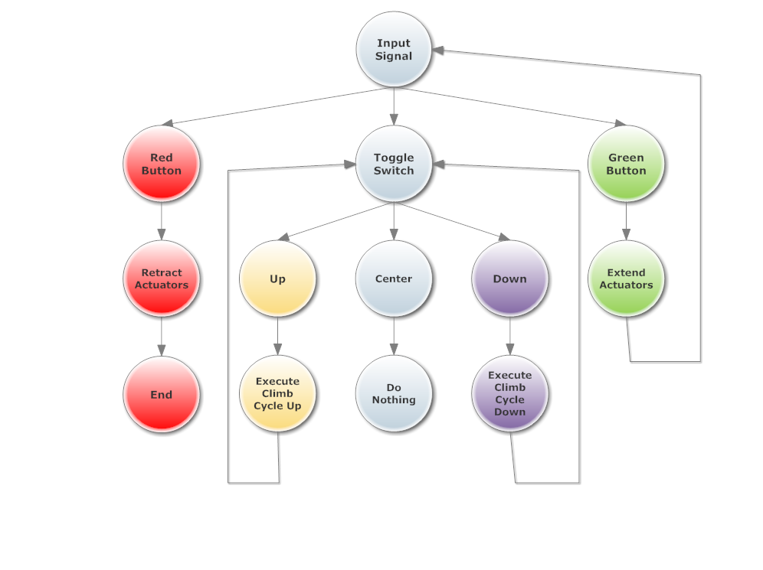

# Quality Function Deployment

The tools we utilized in our measure phase include a Venn diagram, a Pugh Selection Matrix, House of Quality, as well as a Traditional Selection Matrix. These tools would help us determine which robot would be most successful.

The House of Quality gives technical weights to each requirement showing the importance of each factor. From this, we decided to concentrate on the efficiency of the machine, the weight of the robot, as well as the costs associated with each design concept concerning materials and production. For the efficiency aspect, we are including variables such as time, power, and the overall force required to climb the tree. These requirements, shown highlighted, scored relatively high in our correlation matrix and will be the main focus of our design.

Figure 2: House Of Quality (HoQ)

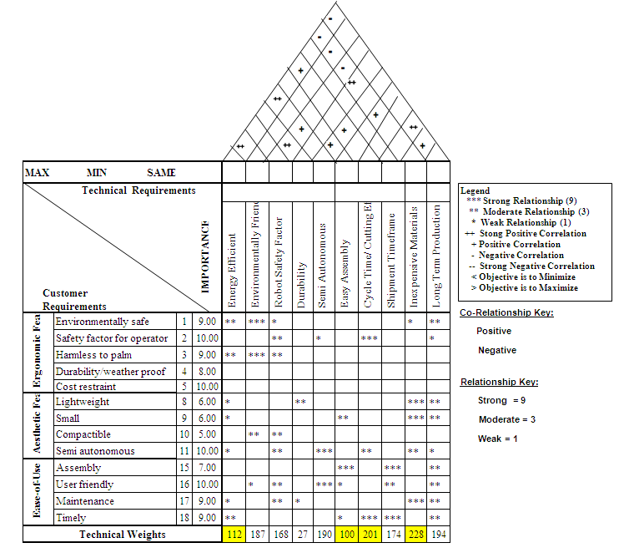

Figure 3: Venn Diagram

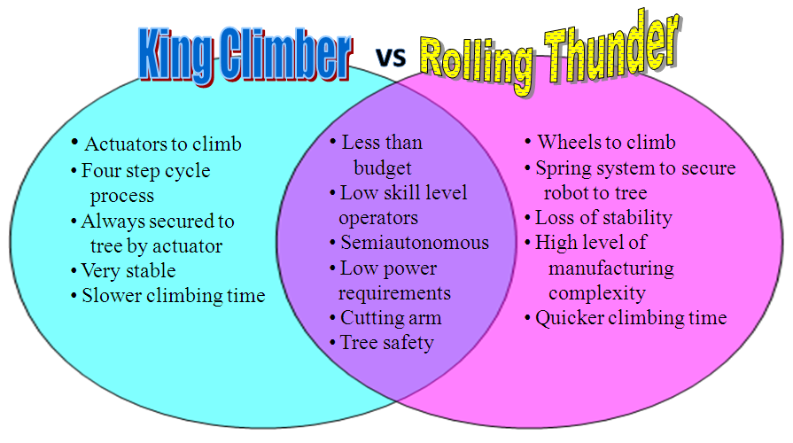

This allows us to visualize between both design concepts so that we can see both similarities and differences between both ideas, which will ultimately lead to the more optimal design selection. The differences in the two concepts will be the deciding factors, because the similarities essentially cancel each other out.

Figure 4: Pugh Selection Matrix

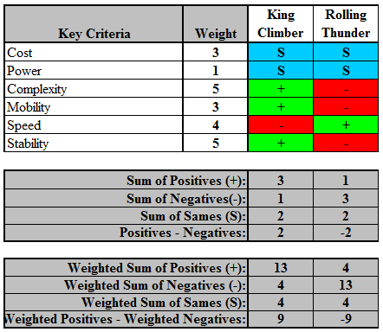

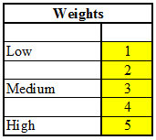 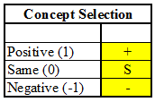

**Matrix Keys:**

This is very helpful in the selection process because it is designed to evaluate multiple options against each other, relative to a baseline option. It is more commonly known as a selection or decision matrix for this reason. The goal of the Pugh Selection Matrix is to maximize the major parameters while the goal of the other selection matrix will be to minimize the other major parameters. However, this method does have a flaw in that we cannot account for qualitative factors. On the other hand, we will be able to assess distinct factors such as: complexity, stability, and mobility. As a result, we can compare the concepts on a general basis, and not just the numerical values, which could be irrelevant if the overall design is flawed. Based on the sum values, we will be able to determine which design will be the better choice. First we must add up all the positive, same, and negative signs per column. After we get a numerical value based on the concept selection key, we must multiply those values by the weights that we assigned to each of the respective criteria. Once we do this step, we can compare the concepts with a more relative scale.

Figure 5: Traditional Selection Matrix

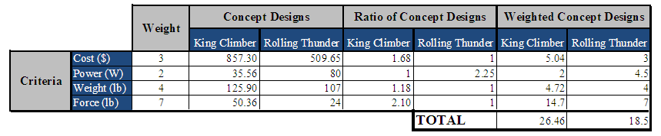

A Traditional Selection Matrix takes into account the different metrics that we used to define our two concepts. The different metrics helped us compare the different quantitative values. The goal of the selection matrix is to calculate a weighted value and choose the lowest sum of the calculations. The only downside to this table is the fact that we could not include values for metrics such as: speed, complexity, or mobility. The reasoning behind this is that this particular selection matrix is based on finding the lowest value. If we were to include speed, it would give us an inaccurate reading because, in actuality, we would prefer the robot that has the fastest speed. If we were to include speed and give it the appropriate weight rating, it would favor the slower robot.

# Project Plan

The planning of the project in all major aspects was set by the requirements of the class. There were several major reports and milestones to be met during the two semesters of the project duration. There were some project specific goals and datelines set by the group itself and all of these can be seen in the Gantt chart explain and displayed in the next section. Also, our project mentor make request of the group intermittently throughout the project to focus the group on time sensitive subjects.

## Gantt Chart

The use of a Gantt chart is crucial for every project because it allows for the planning and management of various tasks. By referencing our Gantt chart, we can monitor the achievement of project goals, as well as, see if we are up to date on all of our deadlines. According to our Gantt chart in Figure 6, we are approximately 2 weeks behind our goal of testing our prototype. This is due to the fact that we have encountered numerous obstacles, which will be discussed in the obstacles encountered section.

Figure 6: Gantt Chart

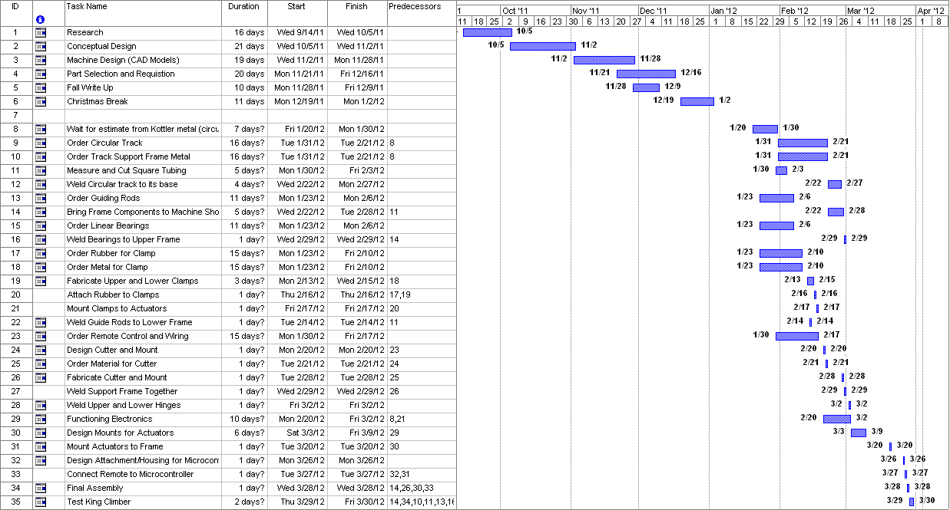

# Engineering Analysis of Concept Designs

Engineering analysis was utilized to calculate and evaluate both concept designs. Both sections portray the thinking process our group went through in order to calculate the necessary numeric values needed to justify our end decision. Both the following sections will focus on providing results to the following:

1. Generate an estimated total weight of the climber including a cutter payload
2. Using our physics and engineering classes, calculate:
   1. the amount of force need to keep the climber on the tree
   2. the amount of power needed to make the robot climb
   3. the speed at which it can climb
3. Check the compatibility of the materials and make sure

that they can handle the forces

1. Select hypothetical parts and components, calculate rough cost estimate based on

prices given by various companies for specific parts

## 

## Concept 1: King Climber

The King Climber design was one of our major concepts that made it to the analysis phase. The Pro-Engineer model below is broken into five main components depicted in Figure 7. The first component consists of the track for the manipulator arm and is located at the top having a separate frame. Next, four guiding rods are secured to each corner of the lower frame in order to keep the top and bottom frames aligned. Another major component is the upper frame. The upper frame guides the device up the palm tree. Moving downwards, vertical actuators are placed on the adjacent side of the hinges along the center line of the frame. This allows the entire device to be lifted upwards. Finally, the last major component consists of multiple thick horizontal rods that are placed into the square frame. They are placed into the square frame utilizing grappling plates attached to the horizontal actuators and are the mechanism that provides the required force to keep the device attached to the tree.

Figure 7: Pro-E Model for King Climber

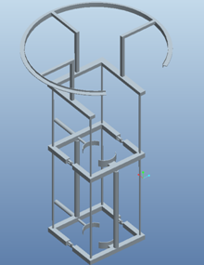

The Pro-E simulation of King Climber illustrates a computer generated prototype of the design. This allows us to visualize what is happening in the design as well as obtain a practical representation of the anticipated applied loads and stresses experienced. By utilizing the Pro-E software, we can easily show the various degrees of stresses applied to the design at various points via contour plot. Even though all actions in the concept design cannot be accounted for in a laboratory or experimental setting, creating Pro-E simulations are the best technique in order to evaluate and measure the potential concept design. This technique allows the user to grasp a full understanding of how King Climber works. In addition to providing graphical representations of data, we also utilized Pro-E to generate animations to display the functionality of our design. This way, we can convey the capabilities of our product verbally, visually, and virtually to our customers without requiring them to actually engage in physical contact with the machine in order to fully understand and become comfortable with the product.

Each component of the King Climber has its own corresponding contour plot that shows the maximum stress points experienced from the load imposed on the machine at these points. These aid in the engineering analysis and distinguish between which area needs to be strengthened. Also, it allows us to verify that the material chosen can withstand the expected stresses. For example, on Figure 8 the largest load is experienced at the bottom corners of the tree grappling clamps. This is indicated by the red color on the contour plot. This section was anticipated to have the largest stress because this contains the points where the majority of the force will be put on the machine to safely secure it to the tree. Ideally, the load will be evenly distributed along the grappler but, due to the geometry of the tree grappler that was not feasible.

Figure 8: Finite Element Analysis on the lower actuator frame

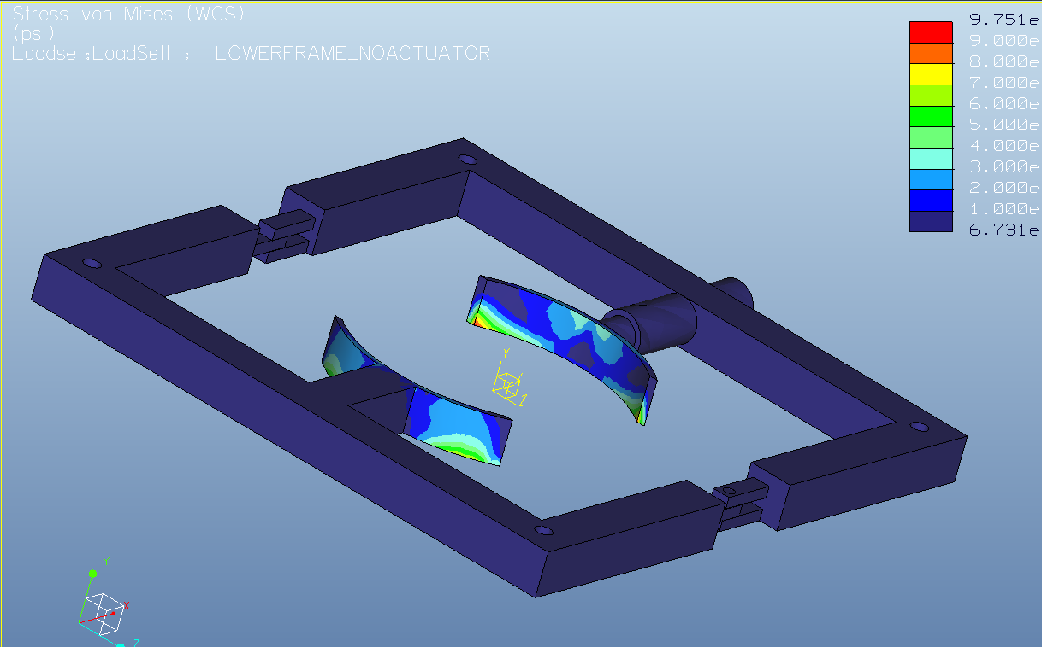

In Figure 9, four guiding rods are implemented in the lower frame. This image portrays the stresses in the vertical actuators as well as the guiding rods. All four guiding rods show uniform loading on the vertical support rods. These results show that these stresses fall within the acceptable range for the material selection.

Figure 9: Finite Element Analysis of Lower Frame

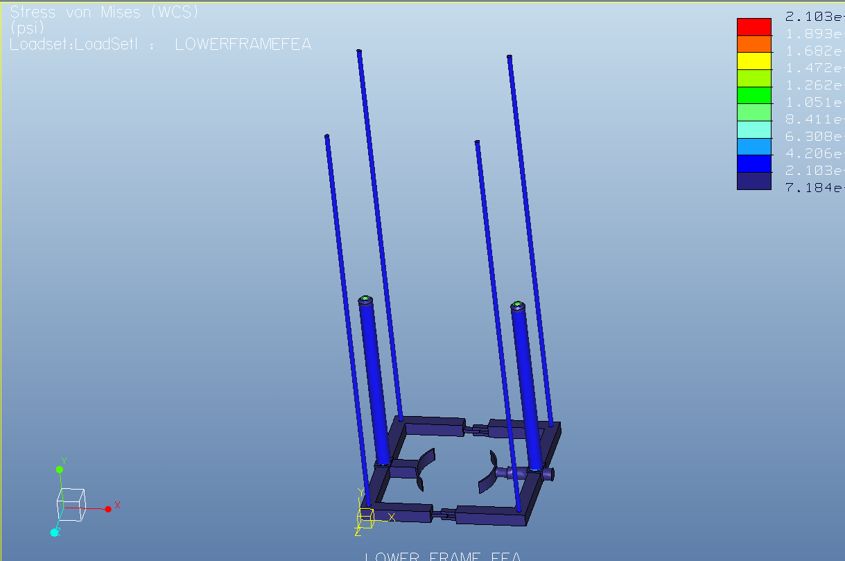

In Figure 10, finite element analysis was used to analyze the manipulator track having a

payload of 50 lbs. The arrow depicts where the point load is applied. This image shows that

there is a high stress concentration near the welds between the frame support and the circular

track, as well as locally near the point where the load is applied.

Figure 10: Finite Element Analysis on the manipulator track

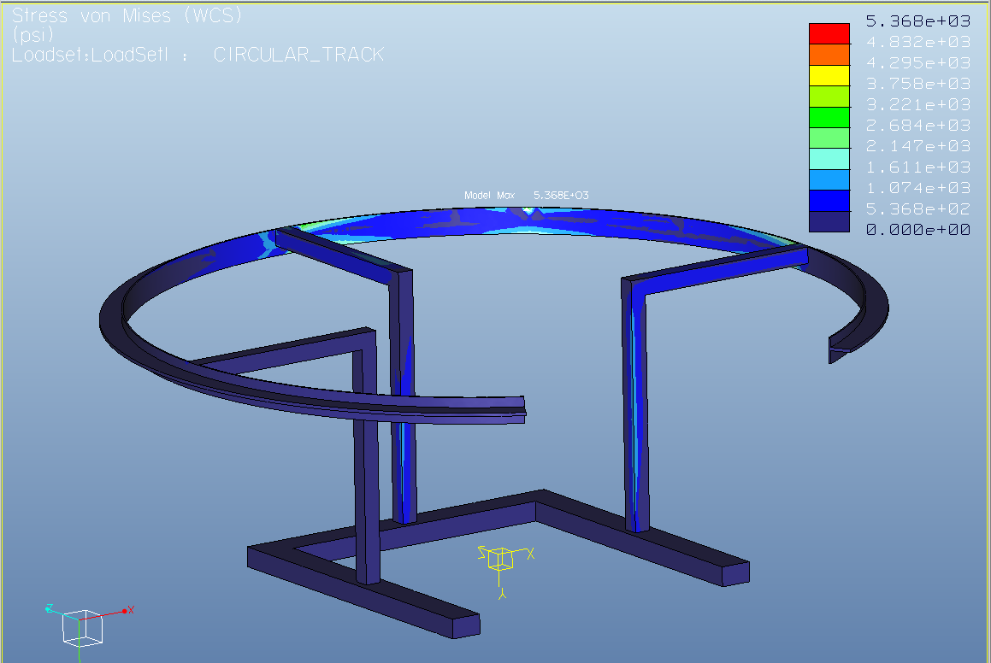

## Results of Analysis of Design:

**#1: Testing Geometry and Calculating Weight**

Geometric Calculations

The first step in our calculations is to determine the amount of material used. To do this, we must first calculate the dimensions of our robot. Assuming a diameter of 14 inches for the tree, we decided that the robot would only climb trees ranging from 8-17 inches in diameter. So we will essentially be working with a 26” x 26” square frame for the top and bottom horizontal actuator. We must also take into account the frame itself.

$P=2l+2w$

$$P=2\left(26"\right)+ 2\left(26"\right)=104"$$

Figure 11: Frame Cross Section

$l$ 26” $w$ 
   
  
  
  
  
 26”

We have selected Aluminum 6061 2” x 2” square tubing for the frame, given its mechanical properties and weldability. Since our design requires both an upper and lower frame, we must multiply this number (104”) by 2.

After the amount of material needed for the frame is found, we have to calculate the amount of material needed to produce the track that the cutter will move around on. Since we need to cut all around the top of the tree, we will place a cutting track on the top of the top frame which will allow the cutting arm to rotate 270° around the tree. We will not be able to emcompass the entire tree with the cutting track, so it will be an opening on the front end of the robot. We will use 6 straight tubes as the supports for the circular track and a single T-beam as the track itself. Each support tube will be 16 inches long and the track will be 129.59 inches long.

$Aluminum track Circumference=\frac{270}{360} \left(2π* r\right)=129.59 in$

Weight Calculations

The first step in figuring out the weight of the robot will be determining the total amount of raw material we will use. We must consider the material that it takes to build the upper and lower frame, along with the cutting track. This is summarized in Table 1.

Table 1: Material Lengths Required

|  |  |
| --- | --- |
| **Raw Material Lengths (Al6061)** | **Inches** |
| Upper | 104 |
| Lower | 104 |
| Track Supports | 96 |
| Track | 130 |
| **Total Al6061 T-beam needed** | 130 |
| **Total Al6061 square tubing needed** | 304 |

$Square tubing required=304 in (\frac{1 ft}{12 in})$ = 25.3 ft.

Next we found the density of Al 6061 to be $0.0975\frac{lb}{{in}^{3}}$ from a metal supply store. We used this density to find the weight of the material used shown in Table 3.

$m=d×v$

$$d≡0.0975\frac{lb}{{in}^{3}}; v=\left(2.0*2.0*304\text{)-(1}.5*1.5*304\right)=532 {in}^{3}$$

$$m=0.0975 \frac{lb}{{in}^{3}}×532 {in}^{3}=51.87 lb$$

Table 2: Actuator Selection

|  |  |  |  |  |  |  |
| --- | --- | --- | --- | --- | --- | --- |
| **Actuator** | **Stroke (in.)** | **Length (in.)** | | **Weight (lb.)** | **Speed ($\frac{in.}{sec}$)** | **Cost** |
| **Closed** | **Open** |
| Horizontal | 8 | 17.5 | 25.5 | 5 | 3 | 129.00 |
| Vertical | 30 | 37.88 | 67.88 | 7 | 2.5 | 169.99 |

When dealing with the overall weight we must also include the weight of the actuators along with the weight of the cutter. This is depicted in Figure 5c.

Table 3: Individual Weights

|  |  |
| --- | --- |
| **Material** | **Weight (lbs)** |
| Frame (both upper and lower frames) | 51.9 |
| Actuators [2*(horizontal actuators) + 2*(vertical actuators)] | 24 |
| Cutter | 50 |
| Supports | 18 |
| Total | 143.9 |

**#2A: Calculating force to keep the robot on the tree**

Our initial step was to create a free body diagram shown in Figure 12. This diagram shows the major forces acting on the tree trunk as well as the location of the actuators.

Figure 12: King Climber Free Body Diagram

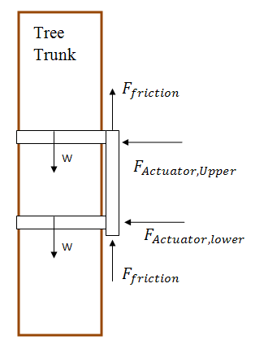

Horizontal Actuator Selection

$F_{friction}={ μ}_{rubber}* F_{normal}$

$$F_{actuator}=F_{normal} ; { μ}_{rubber}=2.5$$

$${ F}_{friction}= { μ}_{rubber}* F_{actuator}= W_{total}$$

$$W_{total }=W_{actuators}+W_{frame}+ W_{cutter}= 24lbf+ 51.9 lbf+50lbf=125.9 lbf$$

$$F_{actuator}= \frac{W_{total}}{{ μ}_{rubber}}=\frac{125.9 lbf}{2.5}$$

$$F_{actuator}= 50.36 lbf$$

The whole idea here is to make the force of the robot’s weight equal to the force of friction holding the robot up. The governing equation to do this is

$$F_{friction}=μ_{rubber}*F_{Actuator}$$

and must

$$F_{friction}= F_{gravity}$$

With the weight of the climber being 125.9 lbs and the coefficient of friction of 2.5, then we solve that the force required by each, the upper and lower actuator, to keep the robot on the palm tree is **50.36** pound-force.

Vertical Actuator Selection

$ΣF_{y}=0$

$$-W_{lower actuator}-W_{upper actuator}- W_{cutter}- W_{frame}+ F_{actuator}=0$$

$$F_{actuator}= W_{horizontal actuators}+W_{vertical actuators}+ W_{cutter}+ W_{frame}$$

$$F_{actuator}=10 lbf+14 lbf+50 lbf+51.9$$

$$F_{actuator}=125.9 lbf$$

This shows that the forces required in the Y-axis by both vertical actuators in order to keep the robot on the tree palm is **125.9** pound-force.

**#2B: Calculate Required Power**

Next we need to calculate the power.

$$F=125.9 lbf=560 N$$

${ P}_{required}=F×v=560 N*2.5\frac{in}{sec}$

$$P_{required}=35.56 watts$$

$$12 sec=0.0033 hrs$$

$$35.56 w ×0.0033 hrs=0.117348 watt*hours$$

$P_{Total}=\sum_{0}^{t}{\frac{Δw}{Δt}}=\frac{\left(4\right)\left(50.36 lbf ×6 in\right)+\left(125.9 lbf ×30 in\right)+(85.95 lbf ×30 in)}{\left(4\right)\left(2 sec\right)+\left(12 sec\right)+(11.3 sec)}$

$$P_{Total}=241.67 watts$$

**#2C: Speed Calculation**

After calculating the power, we must calculate the speed at which the robot will be able to climb the tree.

$velocity= \frac{distance}{time}$

In order for it to be calculated the total time in a cycle has to be evaluated by the Climbing Routing:

1. Secure lower actuator to the palm tree:
$$t= \frac{L_{stroke}}{v_{actuator}}= \frac{6 in}{3 \frac{in}{sec}}=2 sec$$

2. Secure lower actuator to the palm tree:
$$t= \frac{L_{stroke}}{v_{actuator}}= \frac{30 in}{2.5 \frac{in}{sec}}=12 sec$$

3. Secure lower actuator to the palm tree:
$$t= \frac{L_{stroke}}{v_{actuator}}= \frac{6 in}{3 \frac{in}{sec}}=2 sec$$

4. Secure lower actuator to the palm tree:
$$t= \frac{L_{stroke}}{v_{actuator}}= \frac{6 in}{3 \frac{in}{sec}}=2 sec$$

5. Secure lower actuator to the palm tree:
$$t= \frac{L_{stroke}}{v_{actuator}}= \frac{30 in}{2.65 \frac{in}{sec}}=11.3 sec$$

6. Secure lower actuator to the palm tree:
$$t= \frac{L_{stroke}}{v_{actuator}}= \frac{6 in}{3 \frac{in}{sec}}=2 sec$$

7. Retract upper actuator:

$$t= \frac{L_{stroke}}{v_{actuator}}= \frac{6 in}{3 \frac{in}{sec}}=2 sec$$

The time required for 30” climbing cycle = 33.3 seconds.

$$\# Cycles required for 45 ft palm tree= \frac{45 ft* ( \frac{12in}{1 ft})}{30in}=18 cycles$$

$$T_{Required to Climb }=\# Cycles*Climbing cycle time=18 cycles ×33.3 sec=9.99 min$$

$$v_{Robot}= \frac{45 ft}{9.99 min}=4.5 \frac{ft}{min}=0.075\frac{ft}{sec}$$

**#3: Testing chosen material strength**

Now that weight and loads have been calculated we need to go back and test the material that was originally selected. Aluminum 6061-T6 is a strong metal with yield strength of 42,000 psi. The weight of the robot is distributed among two actuators, so the load applied to the cross-section of the beam is 62.95 lbs. The stress equation for simple tension is

$$σ= \frac{F}{A}$$

With sigma being engineering stress, F being force, and A being the area that a force is being applied to. The dimensions 2.0" x 2.0" x 0.125", the cross-sectional area of the square tubing is 0.5 ${in}^{2}$.

$$σ= \frac{62.95 lbf}{0.5 {in}^{2}} =125.9 psi$$

2.0”

2.0”

0.125”

**#4: Generate a Rough Cost Estimate**

Based on our previous calculations, we were able to figure out material costs as well as

the companies that we could purchase these materials from. Table 4 provides a summary on

our calculated information.

Table 4: Summary of Concept #1 Design

|  |  |  |  |  |
| --- | --- | --- | --- | --- |
| **Material** | **Weight (lbs)** | **Quantity (unit)** | **Cost ($)** | **Total Cost ($)** |
| AL6061 | 51.9 | 36 ft (Ordered extra) | 5.59 per ft | 201.30 |
| Supports | 18 | 4 | 16 | 64.00 |
| Cutter | 50 | 1 | * | * |
| H Actuator | 5 | 2 | 159.00 | 318.00 |
| V Actuator | 7 | 2 | 169.00 | 338.00 |
| **Total** | 143.9 |  | | 921.30 |

**Total Cost:** $201.3 + $318.00 + $338.00 = $857.30

**Power requirement: $35.56 watts$**

**Maximum applied stress on to Al6061 frame:** 125.9 psi

**Speed: $0.075\frac{ft}{sec}$**

## Concept 2: Rolling Thunder

The Rolling Thunder design was one of the top ideas that became one of our potential design concepts. Shown in Figure 13, the overall design relies on the orange wheels pressed into the tree by the red springs in order to secure itself to the trunk of the tree. Then, after it is secure, it uses the black motors attached to the wheels to drive the wheels up the tree. The frame and legs are light blue and are made out of boxed aluminum. The main structure is rolled into a ¾ circle leaving a gap wide enough to allow the trunk of the tree to be inserted into the center. The outer rim of the circular track is to be used for the guiding rail of the manipulator arm. Also, we created a Pro-E simulation in order to gain a better understanding as to how the Rolling Thunder design will operate.

Figure 13: Pro-E for Rolling Thunder

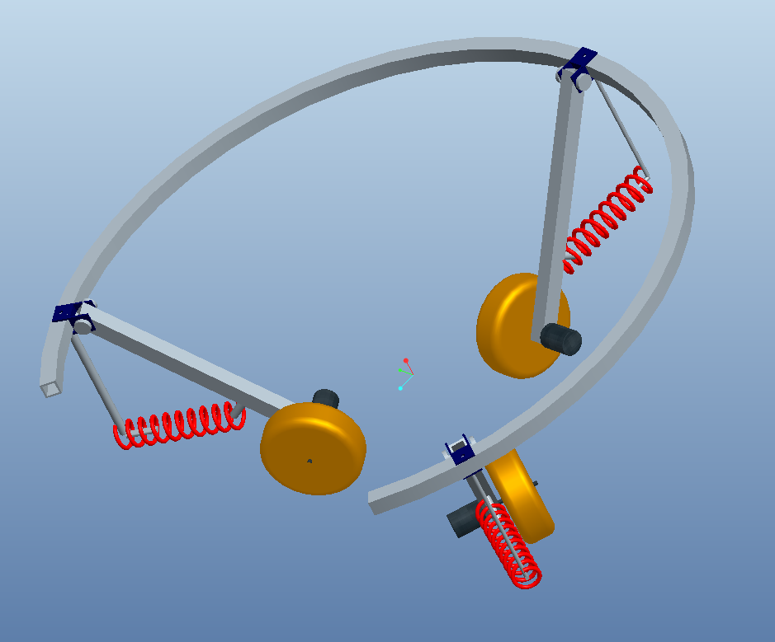

Figure 14 shows the rolling thunder design from a top view. The tree trunk would be located in the center of the three orange wheels and secured by the red springs.

Figure 14: Rolling Thunder Top View

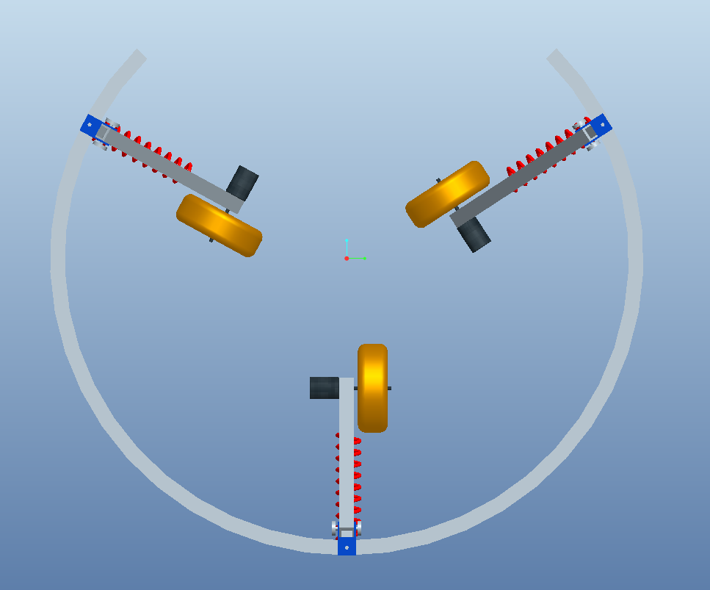

Figure 15 is the side view of the Rolling Thunder design from the perspective of the opening in the main track. The black motors, orange wheels, red springs, and light blue structure are all clearly visible.

Figure 15: Rolling Thunder Side View

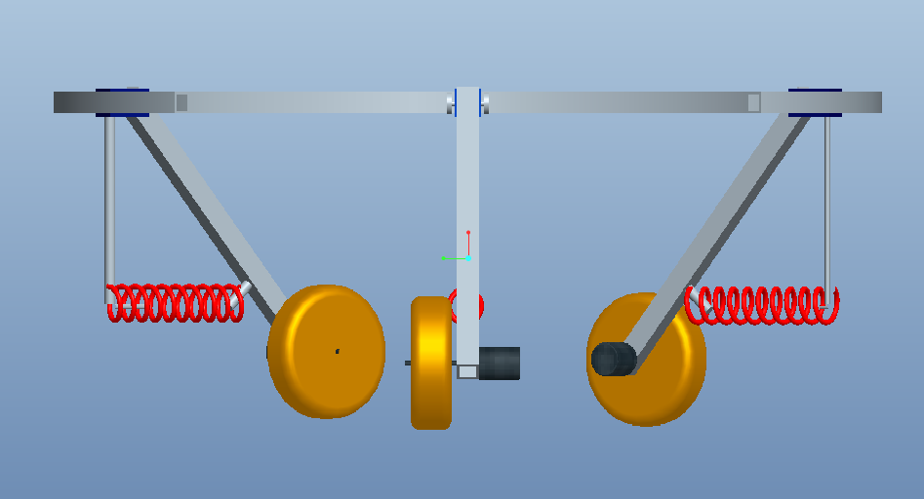

## Results of Analysis of Design

**#1: Testing Geometry and Calculating Weight**

Geometric Calculations

The first step in our calculations was to figure out the average diameter of the palm. We found this to be approximately 14 inches as previously stated in the define phase. After taking this into consideration, we decided that on either side of the palm, there should be at least 12 inches of free space for the actual machine. As a result, the radius of the wheeled robot frame would be 19 inches and the total diameter would be 38 inches. The robot will encompass a total of 270 degrees of the palm. As a result, this concept design must take into account an opening gap of 26.8 inches deduced via Pythagorean Theorem.

$C=\sqrt{A^{2}+B^{2} }$

Next, we solved for the length of the legs required. We utilized SOH CAH TOA, angle at 45 degrees, with a length of 12 inches. The 12 inches accounted for the space between the actual palm and the machine on either side. We obtained that the required length of each leg is 16.97 inches.

$H=\frac{A}{cosϴ}$

Weight Calculations

We chose the opposite side of the open gap as the center with a wheel at 120 degrees in either direction. Also, we took into account the 135 degrees of track on either side from the chosen center. With this, we were able to calculate how much AL6061 was needed so that we could build our robot. The robot encompasses 270 degrees or ¾ of the palm tree. Need material lengths are summarized in Figure 9a.

Table 5: Material Lengths

|  |  |
| --- | --- |
| **Raw Material Lengths**  **(Al 6061)** | **Length (inches)** |
| Circle Track | 89.54 |
| Struts (x3) | 24 |
| Legs (x3) | 48 |
| Total needed: | 161.5 |

Next, we found the density of AL 6061 to be 0.098 $\frac{lb}{{in}^{3}}$ from a metal surplus site. The next step was to calculate the area. We did this by looking at the AL profile 1”x1”x0.125” and calculated the area to be 0.44 ${in}^{2}$. From this information, we found the weights for our individual materials as well as the total weight shown in Tables 5 and 6. The total weight of the concept 2 design was 57 lbs.

Table 6: Material Weights

|  |  |
| --- | --- |
| **Material** | **Weight (lbs)** |
| Frame | 7 |
| Wheels | 18 |
| Motors | 2 |
| Pay Load | 25 |
| Springs | 5 |
| Total | 57 |

**#2A: Calculating force to keep the robot on the tree**

In order to calculate the force, the first step was to create the free body diagram shown in

Figure 16. This allows us to analyze the forces acting on the body.

Figure 16: Free Body Diagram of Rolling Thunder Design

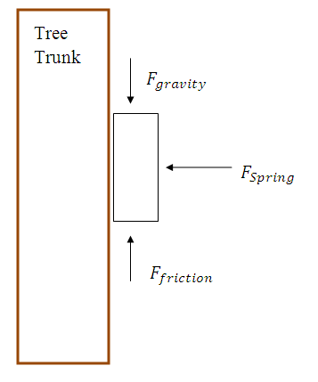

The main objective here is to make the force of the robot’s weight equal to the force of friction holding the robot up. The governing equations to do this are

$F_{friction}=μ*F_{spring}$

and

$F_{friction}≥ F_{gravity}$

The symbol µ is the coefficient of friction. Equation 2.4 must be true for the wheels which means that the robot will stay on the tree. Knowing the weight of the climber to be approximately 60lbs as well as the coefficient of friction for rubber on a solid to be 2.5, we can use this information to solve for the spring force. Calculations show that each spring needs to put at least **24lbs of force** onto the wheels in order to secure the robot to the tree.

**#2B & 2C: Calculating required torque, power and speed**

Next, we need to calculate both torque and power. Torque is governed by

$T=F*r$ (2.5)

with T being Torque, F being force and r being radius. The Figure_ below illustrates how the forces will interact with one another. We found that we need about **15 ft-lbs** of force in order to hold the wheels on the tree and keep the machine from rolling backwards. Figure 17 provides a visual of the forces required in order to calculate torque.

Figure 17: Free Body Diagram Showing Torque Interaction

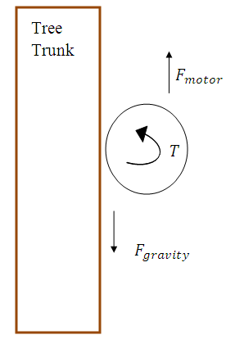

To solve for power the governing equation is

$P=T*w$ with P being power, and w being angular velocity. By setting torque to be 15 lb-ft over the original stall torque and making the robot roll up the tree at a speed of **1 ft/s**, we were able to calculate that the robot requires about 0.1 hp of power.

**#3: Testing chosen material strength**

Now that we have calculated weight and the respective loads, we must go back and test our originally selected material, Aluminum 6061. This is a relatively strong metal with a yield strength of 40,000 psi. In our concept design, the wheel legs must support the most force because they need to be strong enough to act against gravity. Utilizing this information, the weight of 60lbs is divided by the three legs so each leg receives 20 lbs of force on it. The stress equation for simple tension is

$σ= \frac{F}{A}$

with sigma representing the engineering stress, F being the force, and A being the area that the force is being applied to. With the boxed 1"x1"x0.125" Aluminum, the area is 0.44 in2 and has a resulting stress of **45.45 psi** which is much smaller than the 40,000 psi allotted.

These results reveal that the metal will not yield under the stresses applied. The next variable that must be tested is the deflection of the supporting structure under the applied load.

The governing equation for deflection of a beam is

$$δ=\frac{F*L}{A*E}$$

The E is Young’s modulus of the material. Using the entire length of the circular track to represent the beam length, we calculated that this design will give a deflection of 0.3 inches.

**#4: Rough Cost Estimate**

After all calculations were completed, we were able to figure out the specifications

and cost associated concerning each part. A breakdown of the needed material, weights,

quantity, as well as total costs are depicted in Table 7.

Table 7: Summary of Concept #2 Design

|  |  |  |  |  |
| --- | --- | --- | --- | --- |
| **Material** | **Weight (lbs)** | **Quantity (unit)** | **Cost ($)** | **Total Cost ($)** |
| AL6061 | * | 20 ft | 2.57 per ft | 51.40 |
| Wheels | 18 | 3 | 13.00 | 39.00 |
| Springs | 5 | 3 | 5.75 | 17.25 |
| Motors | 2 | 3 | 84.00 | 252.00 |
| Generator (1000 watt) | * | 1 | 150.00 | 150.00 |

**Total Cost:** $51.40+$39.00 +$ 17.25+$252.00+$150.00= $509.65

**Power requirement:** 73.5 watts

**Stress factor of Al6061:** 45.45 psi

**Force to hold wheels on palm:** 15 ft-lbs

**Speed:** 1 ft/sec

## Evaluation of Combined Results

After utilizing all of the selection tools, we came to the conclusion that the King Climber was the best concept overall. We took into account many different factors to reach this decision. Although one of the designs may produce better results in one selection tool, does not mean that it is the optimal decision. We have to take into account each and every resource at our disposal.

We used the House of Quality from our Define Phase to set our desired criteria for the robot. The define phase determined the parameters that we chose to measure and evaluate for the actual Measure Phase. Basically, our robot needed to be inexpensive, lightweight, require minimal force, as well as be efficient when it comes to climbing up and down the palm tree.

The Venn Diagram helped us determine the similarities and differences between the two

concepts. This is extremely beneficial because we can decide which factors are more important

than others. The reason for this is because if two concepts have similarities, then the similarities

are not going to be the deciding factors. The deciding factors come from the differences in the

concepts.

Another beneficial tool was the traditional selection matrix. This matrix is more result based. This means that the matrix is taking into consideration the quantitative values measured by our team. Basically, the concept with the lower score is the better choice. The Rolling Thunder had the lower score of 18.5, compared to 24.46 for the King Climber. These values alone cannot provide us with the optimal concept design because they are so close. Along with the similarity in numbers, this selection matrix does not include some of the metrics due to the fact that the objective is to choose the lower values.

The King Climber scored the highest value on the Pugh Matrix, which took into account all of the desired criteria. The goal of Pugh Matrix is to score the highest value. The King Climber scored a value of 9 on this selection tool, which is much greater than that of the Rolling Thunder. The Rolling Thunder, consequently, scored a value of -9. When we compare these two values, we get a better look at how the two concepts stack up against each other. The only downfall in the King Climber is that this design climbs at a slower pace than that of the Rolling Thunder. We believe this to be directly correlated to the productivity of our mechanism. As a result, the faster the apparatus can move, the more fruit the apparatus harvests.

In the end, the King Climber concept design appears to be the more promising of the two potential concept designs. Due to our budget of $2000, as well as, our time constraint, we are limited in that we must lean towards a more simplistic, realistic, and achievable design. Both designs are well under our budget constraint; however, King Climber is the better choice because of various factors. Our decision is justified based on the techniques we implemented to evaluate and rank our parameters.

# King Climber Product Design

The King Climber concept design was designed and chosen in the measure phase via various tools. Basically, the semi-autonomous robot will climb up and down the palm tree in an inch worm fashion and cut down the palm fruits utilizing a cutting arm. Visualization of the actual cutting will be achieved through the use of a detachable remote controlled camera. The camera will be placed on the mainframe of the palm pruner respective of the area to be cut. This will ensure that the fruits will be extracted from the palm effectively and efficiently.

Our King Climber concept design consists of five major components. These are depicted on the next page in Figure 18. Keep in mind that this Pro-Engineer image excludes the cutting arm. From top to bottom, the upper frame consists of a circular track for the manipulator arm followed by four guiding rods secured to each corner of the lower frame. The guiding rods allow for alignment of the two top and bottom frames. Another major component is the upper frame. The main purpose of the upper frame is to guide the device up and down the palm tree. Moving downwards, vertical actuators are placed on the adjacent side of the hinges along the centerline of the frame. This allows the entire device to be lifted upwards. Finally, the last major component in this design consists of multiple thick horizontal rods placed into the square frame. They are placed into the square frame via grappling plates attached to the horizontal actuators. This is the force that keeps the semiautonomous robot attached to the palm tree. Analysis of the design completed in the measure phase can be referenced in the Appendix. This section provides more information on the Pro-Engineer model and utilizes Finite Element Analysis to portray various loads and stresses on the semi-autonomous robot.

Figure 18: Pro-E Model for King Climber



5

4

3

2

1

|  |  |
| --- | --- |
| Part # | Description |
| 1 | Circular track |
| 2 | Guiding rods |
| 3 | Upper frame |
| 4 | Vertical actuators |
| 5 | Square frame |

Found on the next page, Figure 19 portrays the cutting arm concept design chosen for the King Climber. The cutting arm is able to function by using a DC motor coupled with a large circular saw blade attached to a square tube shaft. The saw blade will travel around the tree by use of castor wheels located on the circular track. One of these castor wheels will be powered by a geared DC motor. The shaft will be able to extend, retract, and rotate to maneuver the blade into the optimal cutting position. Based on the user’s preference, the camera can be mounted on either the cutter shaft or the aluminum housing. Due to the existing time constraint, the cutting arm will not be fabricated by our projected deadline. This will be a continued project for next year’s senior design team.

Figure 19: Cutting Arm Concept

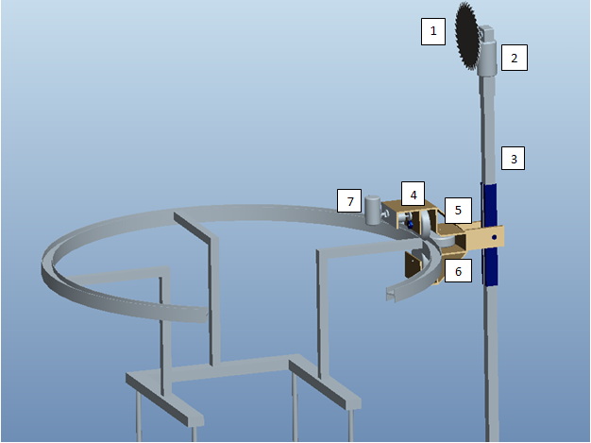

|  |  |
| --- | --- |
| Part # | Description |
| 1 | 8.25” Saw Blade |
| 2 | DC Saw Motor |
| 3 | Al. Shaft |
| 4 | Geared DC Motor |
| 5 | Castor Wheels |
| 6 | Al. Housing |
| 7 | Camera |

## King Climber Interactions

There are various functions and actions involved in operating the King Climber. This section is provided to descriptively layout each process. These processes can be broken down into two main categories: 1) Human Interaction with the King Climber and 2) King Climber’s Response to Human Command. Each category will be broken down into the procedural steps necessary to accomplish the task of harvesting the oil palm tree’s fruit. These process requirements will aid in the understanding of the overall concept of the King Climber. We will begin with Human Interaction.

## Human Interaction

1. Transportation of the King Climber and components (generator, remote controller, etc) to site.

This involves the most physical portion of the operation for the human. The device will have to be carried to the plantation and set up for installation.

1. Attach King Climber to tree.

Attach device to the base of the tree by the four v-shaped grapplers (two at the top and two at the bottom).

1. Set up connections.

Make sure all of the proper connections are made between the King Climber and its components.

1. Verify generator is running and King Climber is getting power by checking if the power indicator light is on.
2. Verify camera is powered up and is working properly
3. Verify remote is connected and cutter device is functioning properly.
4. Double Check Connections.

Verify all of the components and electrical feeds are installed and attached properly. For example, make sure the grapplers are secured to the tree trunk.

1. Attach Cutting Track.

Place cutting track onto guiding rods.

1. Start Ascension.

Push the “climb up” button to initiate the robot’s systematic ascension up the tree. This will start the process.

1. Fruit Harvesting.

Once the robot has reached the top of the tree, use the remote controller to maneuver the camera and cutter arm to remove the desired fruit from the tree.

1. Start Descent.

Push the “climb down” button to initiate the robot’s systematic descent down the tree. This will end the process.

1. Detach King Climber.

Remove the device from the trunk of the tree. Move to the next tree and repeat steps 3-7.

Obviously, the most crucial functions are carried out by the device itself due to the autonomous nature of the King Climber. As a result, this is where the focus of the procedure will reside. The following will describe the King Climber’s response to human command.

## King Climber’s Response to Human Command

1. Establish all Connections.

Connect all of the components appropriately. For example, make sure that the remote is effectively sending signals to the camera and control arm before the climber begins ascent.

1. User Presses “Climb up” Button.

Once the “climb up” button is pressed by the user, the King Climber springs into action. This starts the climbing process.

1. Ascension.

The King Climber will begin climbing by completing a sequence that will be repeated (looped, in programming code) until the desired distance is traveled along the tree. This is accomplished by the top two grappler arms releasing their grasp and then retracting in the same fashion as the top two did previously. Now, the support arms will also retract, bringing the bottom grappling arms upwards toward the rest of the machine resulting in the original position (in regards to proximity from the top two grappling arms), but just further up the tree. Now, the bottom grappler arms extend and re-establish a secure grip on the tree trunk. These motions will be reoccurring until the King Climber arrives at the top of the tree. (No human interaction involved for the duration of this step)

1. Fruits of our Labor.

Now that the King Climber is at the top of the tree the operator must command the device to remove the fruit from the tree through remote communication. The camera will be mounted on the cutter (manipulator) arm, which revolves around the circular cutting track. The user will maneuver the camera to view the fruits to harvest and push the “harvest” button to begin the cutting of each bushel of fruit from the tree.

1. Cutting the Fruit.

Once the “harvest” button is pushed, the cutting tool will start spinning in the manner of a circular saw blade and gradually separate the fruit from the tree.

1. Descent.

Now that the desired fruit is cut from the oil palm tree it is now time to climb down the tree. Once the user presses the “Climb down” button, the King Climber will begin its descent of the tree in essentially the same manner that it did during the ascent process. The only difference is that instead of the top two grappling arms retracting and releasing first, they will follow the motion of the bottom two grappling arms. In other words, the bottom grapplers will release, retract, and the support arms will extend downwards first, while the top grappler arms remain secured to the trunk of the tree. Then, the grasp of the bottom two grapplers will be re-established and the top two grapplers will then release, retract, and follow the support arms down, then re-establish a secure grasp on the tree themselves. This will be repeated until the device reaches the base of the tree again. (No human interaction involved for the duration of this step)

1. Turn off Power.

Shut down all electrical components before removing and transporting device from tree to tree.

1. Detach King Climber.

Remove the device from the trunk of the tree. Move to the next tree and repeat steps 2-7.

## Tool Selection

Throughout this project, we have utilized various tools in order to aid in the fabrication of the King Climber. Tools include, but are not limited to, a comprehensive Gantt chart, a process chart, a thorough cost analysis, as well as, prototype pilot testing. These tools allow us to analyze various process operations, as well as, aid in the development of our semi-autonomous robot.

## Parts and Assembly Process Chart

Below, Table 8 describes the specific parts and individual assembly processes needed to complete the fabrication of the King Climber. In order to accurately verify the function and use of each part, we have consistently utilized the help of our advisors. This is beneficial for us in that it will allow us to complete this project in the most efficient manner.

Table 8: Parts and Assembly Process

|  |  |  |  |
| --- | --- | --- | --- |
| **Part** | **Assembly Location & Description** | **Testing Process** | **Advisors** |
| Actuators | Both horizontal and vertical actuators will be connected to the frame of the King Climber by attaching them to mounting brackets and then, drilling them to the frame.  This will be done in HPMI. | Brought to the electrical lab and connected to a variable power source to verify proper functionality. | Dr. Chuy: *Assistant Scholar Scientist (ME)*  Mr. Ford: *COE* *Electrical Specialist (EE/CE)* |
| Frame | The frame will be constructed out of aluminum tubing and cut into proper lengths for construction.  This will be done in the COE Machine Shop. | We performed the proper stress calculations and verified material properties. | Jeremy: *COE Machine Shop Lead Specialist*  Jerry Horne: *Machine Shop Specialist (HPMI)* |
| Circular Cutting Track | Material partitioned and effectively welded (as well as bended) to form the desired semi circular shape of the cutting track.  This will be done at Kelly’s Sheet Metal Inc. | N/A | Dr. Kosaraju: *Adjunct Faculty (ME)*  Jerry Horne: *Machine Shop Specialist (HPMI)*  Dr. Hovsapian: *Adjunct Faculty (ME)* |
| Guiding Rods | Connected to the frame via mounting brackets, actuators, and then, drilling to frame.  This will be done at HPMI. | We performed the proper stress calculations and verified material properties. | Jerry Horne: *Machine Shop Specialist (HPMI)* |
| Microcontrollers | Will be wired to the King Climber.  This will be done in HPMI and ME Megatronics Lab | Created circuit schematics and wiring diagrams with assistance from Dr. Chuy in the ME Megatronics Lab. | Dr. Chuy: *Assistant Scholar Scientist (ME)* |
| Cutting Mechanism | Will be attached to the circular track and have mobility along the circular track via wheeled mounts.  This will be done in HPMI and COE Machine Shop. | N/A | Dr. Kosaraju: *Adjunct Faculty (ME)*  Jerry Horne: *Machine Shop Specialist (HPMI)*  Dr. Hovsapian: *Adjunct Faculty (ME)*  Dr. Shih: *Professor (ME)* |

## 

## Pilot Testing

Pilot testing is a small scale preliminary study done to improve upon the study design before a full scale implementation of the project. It is essentially the first look as to how the product will function. This step is crucial because it provides valuable insight as to how the product will turn out. If problems due result, it allows for necessary changes or implementations that must be made to the prototype. The prototype that we will be testing is the King Climber.

Not only will pilot testing show any indiscretions, it will also give us a necessary performance result. These results will help us gage how effective the King Climber will be in the business world. The results produced from this, will be compared to current methods in order to accurately understand the effectiveness of the product. Unfortunately, as mentioned earlier, we are slightly behind schedule, approximately 3 days. The pilot testing will take place on the March 29th and 30th. Since oil palms are not native to our location, we will select a tree that is similar. The King Climber will be attached to the base of the selected oil palm and will climb to the top. All actions of the King Climber will be noted and monitored, including the set up time, the actual climb time, and the break down time. This will provide a rough estimate of the total time the product requires in order to complete the task of climbing the oil palm. Also, keep in mind, the actual cutting process of the fruit palms is not included in this pilot test due to the time constraint. The main goal of this pilot test is to make sure that the King Climber can ascend and descend the palm tree in a safe, timely manner.

# Engineering Economics

The project originally had a budget of two thousand dollars. In the fall semester our original design cost was under eighteen hundred dollars. During spring while building the climber there were several problem encountered and most of them need more parts to come to a solution. There were also unexpected construction costs for the extra labor done outside of the engineering campus. The bulk of the extra expenditures in spring were on electronic components. The final cost of the project was two thousand eight hundred dollars.

Machine Aspect

Using a bill of materials is essential for any business, and for building any product. For this verify phase, new expenditures have been added. All are based on the electronic aspect of our machine and come from the same vendor, McMaster Carr. Total expenditures regarding necessary materials can be found in the Appendix. Like in the previous design phase, some parts may or may not include the fabrication and assembly fee. From the updated bill of materials, we created and calculated a new future worth value of our innovative product. The flow chart can be found in Figure 4. A 500% mark-up percentage is still being used because it was one of our sponsor’s requirements for the actual selling price of the product. Also, using a five-year span cash flow diagram did an accurate comparison between human labor cost and machine cost. The cash flow diagram can be found in Figure 4. For the machine aspect, the new selling price for the King Climber should be approximately $13,042.32and the future value to be approximately $\$339,100.32$.

*Selling Price**=**Total Cost (1 + Mark-Up Percent)*

*=* $2,173.72*(1+5)*

*= $13,042.32*

$Future Value=PV (1+rt$*)*

$FV=\$13,042.32(1+(5)(5)$*)*

$$FV=\$339,100.32$$

Figure 19: Present/Future Flow Chart

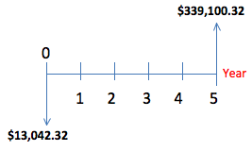

As expected, the future value increased again in this verify phase. The increase in future value is a projection of the increase in selling price. To be precise, the selling price increased from $11,617.62 to $13,042.32 and the future value increased $302,058.12 to $339,100.32. The selling price is higher because we are adding the electronic kit, including seven new products that will make the King Climber work as we expected to. The cutting tool is the only missing product that will increase the cost and selling price of our prototype.

## Human Labor Aspect

From Table 9 below, we were able to describe a real life situation that we have been using since the analyze phase. The situation is based on an oil palm farm employing 16 palm pruners who can each harvest eight oil palm trees a day cutting approximately five bunches per tree. This results in approximately a salary of $80.00 per day at $2.00 per bunch cut. This may not seem as an expensive cost; however, when compared to the actual application of the King Climber to existing oil palms, results show an increase in potential profit. An increase in profit can be seen, since in this real life situation costs of health care are neglected, and with the use of the King Climber they will be reduced or eliminated. The cost to employ 16 palm pruners is approximately $307,200.00. From this, we can calculate a future worth cash flow diagram based on a five-year period utilizing a 5% interest rate. Figure 5 shows the resulting cash flow diagram. The future worth value for labor we obtained was of $384,000.

Table 9: Summary of Process Times

|  |  |  |
| --- | --- | --- |
| **Time** (**in minutes)** | **Process** | |
| **Machine** | **Human** |
| **Climb** | 13.5 | 10 |
| **Cut** | < 5 per bunch | 1 per bunch |
| **Descend** | 13.5 | 10 |
| **Unhook** | 5 | 10 |
| **Transport** | 2 | < 1 |
| **Setup** | 5 | 10 |
| **Total** | 44 | 42 |

$$FV=PV \left(1+rt\right)$$

$$FV=\$307,200\left(1+(0.05)(5)\right)$$

$FV=\$384,000$

Figure 21: Present/Future Flow Chart

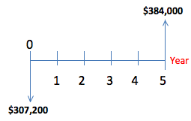

## Breaking Even

Based on the updated information above, a new break even chart can be created. An oil palm farm utilizes 8 King Climber palm pruners can be expected to collect approximately 39.744 metric ton of palm oil, 12.096 metric ton of kernel oil, and 120.96 metric ton of kernel cake. So, if one metric ton of oil palm costs $1,020.54, one metric ton of kernel oil costs $1,366.00 and one metric ton of kernel cake costs $175.00, an oil palm farm will make approximately $939,017.73 in a year [2,3,4]. Because only 2 operators are needed for each King Climber, the cost for labor will be approximately $307,200.00 per year. Figure 4, below, portrays a break even chart for potential plantation owners who invest in purchasing 8 King Climber palm pruners. This break even chart shows that plantation owners will break even before the 1st month of operation. Keep in mind, there is a fixed labor cost of $25,600 per month.

Figure 22: Break Even for Palm Farms Purchase of Machine

We have also included a break even chart to show how many King Climber machines must be purchased in order to start obtaining profit. Company X is renting a facility found in a third world country where every meter square of construction costs $1500.00. Assuming that this facility is 750m2, the construction of this facility is $1,125,000.00 and it is being rented at 1% a month. This means that Company X is spending $11,250.00 a month in rent. Other expenditures include: $350 electricity, $300 cell phone plan, $70 water usage, $400 gas usage, $600 per employee, $600 per secretary, and $1,500 for CEOs. Company X makes use of 8 employees and 1 secretary. So, according to all these costs the fixed cost of operation per month is $19,270.

Our break even chart found on the next page, in Figure 5, shows that if Company X sells 18 King Climber palm pruners for $13,042.32 costing approximately $2,173.72 each, the company can break even at 2 King Climber palm pruners. As a result, the break even chart suggests that Company X will earn approximately $234,761.76 in sales with a fixed cost of $19,270. This is accomplished by assuming a contribution margin of $10,869.

Figure 23: Break Even for Selling Machine

# Results and Discussion

During the design, construction, and fabrication of the King Climber we had multiple tests that had to be run. Due to the numerous parts and components that are vital to the functionality of the machine, we had to perform various tests to verify each respective component and ensure a successful operation. These tests are described below.

***Electrical Components:***

* Microcontroller – We prepared a circuit schematic (see Figure 24) with assistance from Dr. Chuy that illustrated the possible switches, transistors, diodes, etc needed to be constructed on the dragon board to perform the desired tasks. Then, we implemented this schematic on the actual dragon board.

Figure 24: Wiring Schematic

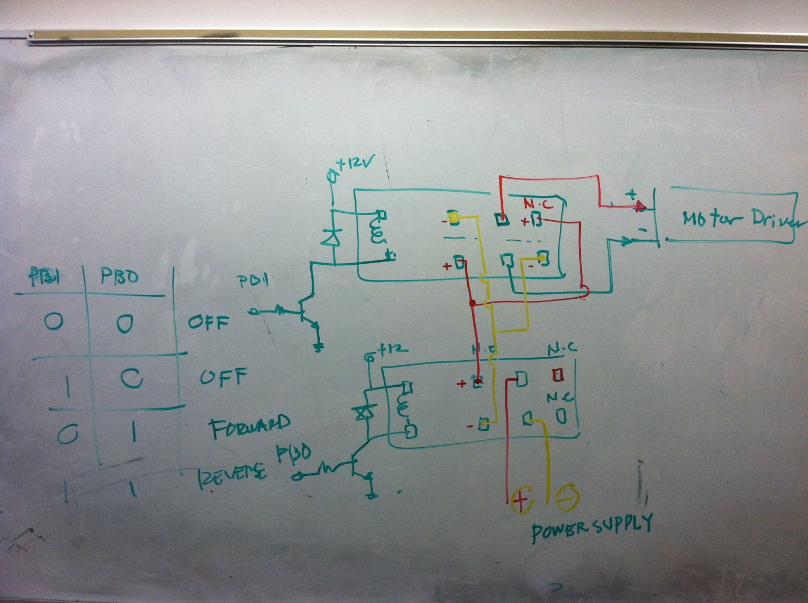

* Switches – We developed programming code to verify that the switches would initiate the process upon being pushed. This was accomplished by testing the signal. We established a wire connection between the push button and the dragon board, compiled our code, and observed what happened. Upon pushing the button, the counter on the LCD display decreased by one, proving that the switch was indeed working properly

Figure 25: Group working on the wiring

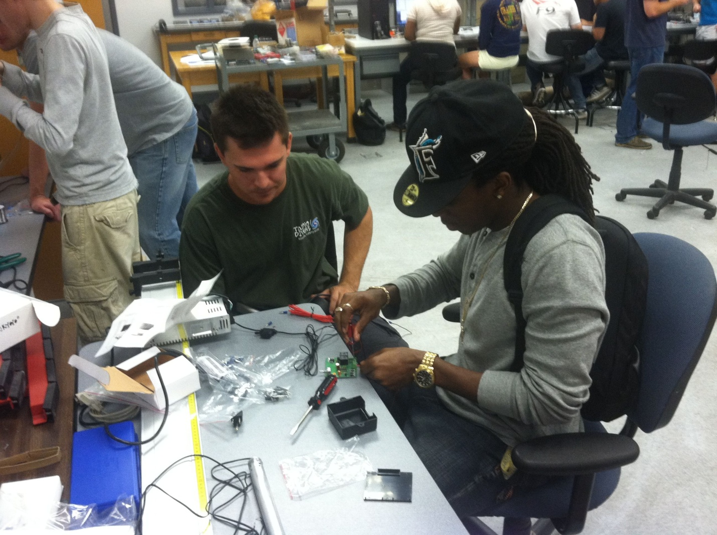

* Actuators – All four actuators were tested individually to confirm that they were all fully functional. They were brought to the electrical lab (operated by Mr. Dante) and tested utilizing an oscilloscope. Once an adequate amount of power was provided (12V and about 11Amps) to the actuator, it extended and retracted on command. The hardest part was establishing a secure connection through the wire attachments to the power source (frustration shown in Figure 26).
* Motor Drivers- Motor drivers were required to run the actuators. They regulated the voltage received and handle the power requirements to motors within the actuators.

Figure 26: Testing the actuator with the power supply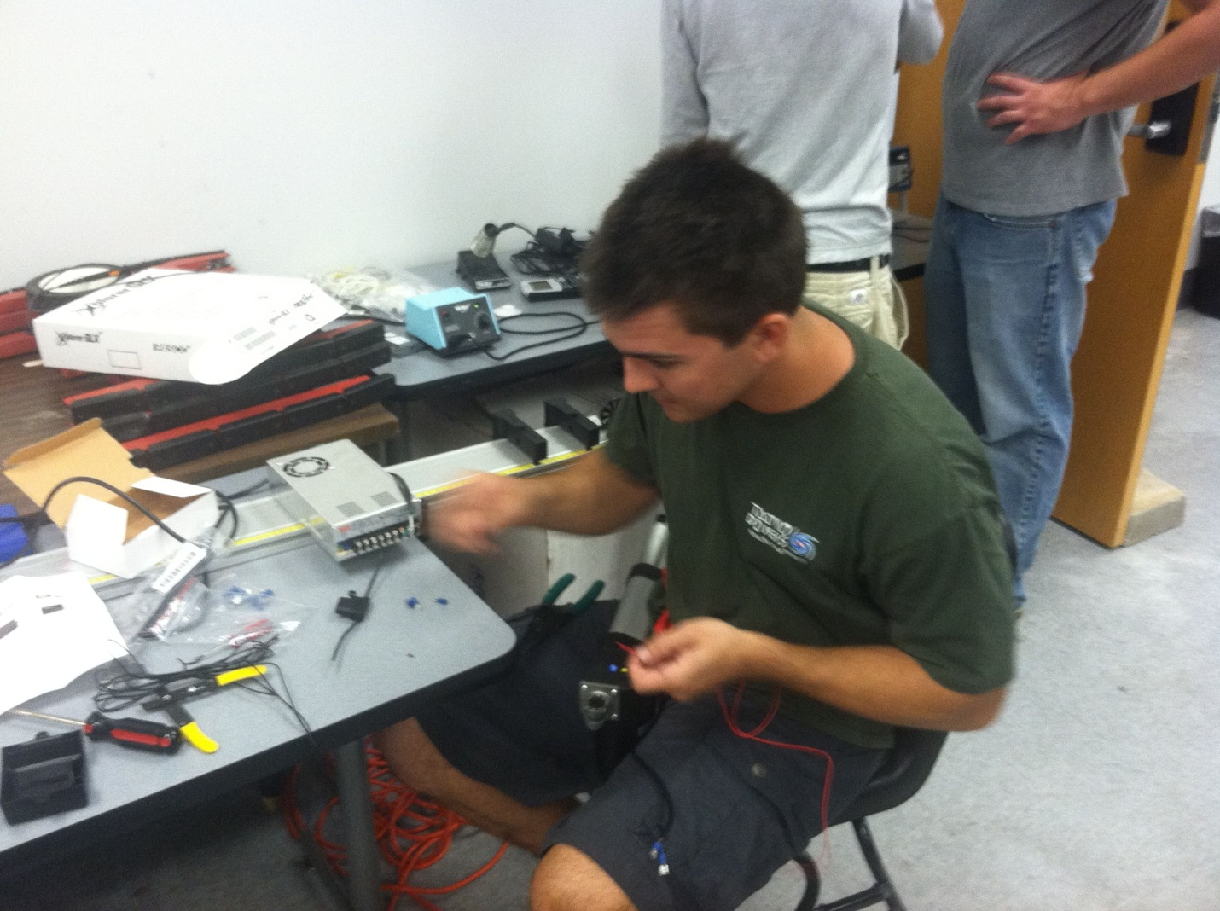

***Structural Components:***

* Bearings & Guide Rods – After constructing the frame and inserting the linear bearings, we tested the willingness to slide along the guide rods in the machine shop. Initially we had aluminum guide rods and steel bearings; that proved to be a problem. The steel bearings were carving grooves into the aluminum rods and impeding the movement of the frame along the rods. After realizing this, we changed the aluminum guide rods to steel ones. This drastically improved the movement of the bearings along the guide rods. We also performed the proper stress calculations and verified material properties.

Figure 27: Constructed frame

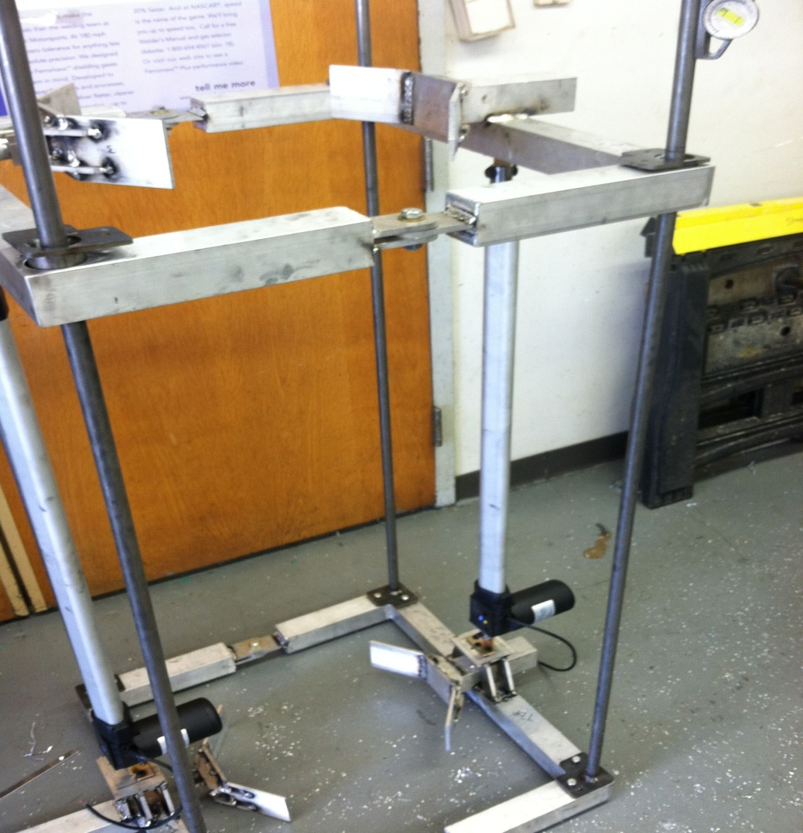

* Bearings – Another problem surfaced with the bearings. As we secured them to the upper frame of our device via bolts, the movement was once again compromised. This prompted us to increase the diameter of the hole to provide more play for the bolts, therefore giving the bearings more slack in the process to move linearly up and down. We were also advised by Jeremy of the machine shop to use delrin (a type of Polyoxymethylene thermoplastic) as our bearings, but when we tried a similar nylon material, that method proved to be ineffective as well.
* Actuator Positioning– We had to construct mounting blocks and brackets for the actuators to sit on and go through respectively. Initially, we were going to have the actuators go through the frame, but discovered that this method could compromise the structural integrity of our design by greatly decreasing the strength by removing material. We didn’t want to risk that, so we decided to solve this issue in this manner (see Figure 27).
* Circular Track and Cutting Mechanism – We purchased the material, had it bended, welded, and had a CAD design created. Unfortunately, we are not fabricating this part of the device due to budget, time, and machinery constraints. This portion will be finalized and optimized by the following year’s group.

Table 10: Assembly Table and Testing

|  |  |  |  |
| --- | --- | --- | --- |
| **Part** | **Assembly Location & Description** | **Testing Process** | **Advisors** |
| Actuators | Both horizontal and vertical actuators will be connected to the frame of the King Climber by attaching them to mounting brackets and then, drilling them to the frame.  This will be done in HPMI. | Brought to the electrical lab and connected to a variable power source to verify proper functionality. | Dr. Chuy: *Assistant Scholar Scientist (ME)*  Mr. Ford: *COE* *Electrical Specialist (EE/CE)* |
| Frame | The frame will be constructed out of aluminum tubing and cut into proper lengths for construction.  This will be done in the COE Machine Shop. | We performed the proper stress calculations and verified material properties. | Jeremy: *COE Machine Shop Lead Specialist*  Jerry Horne: *Machine Shop Specialist (HPMI)* |
| Circular Cutting Track | Material partitioned and effectively welded (as well as bended) to form the desired semi circular shape of the cutting track.  This will be done at Kelly’s Sheet Metal Inc. | N/A | Dr. Kosaraju: *Adjunct Faculty (ME)*  Jerry Horne: *Machine Shop Specialist (HPMI)*  Dr. Hovsapian: *Adjunct Faculty (ME)* |
| Guiding Rods | Connected to the frame via mounting brackets, actuators, and then, drilling to frame.  This will be done at HPMI. | We performed the proper stress calculations and verified material properties. | Jerry Horne: *Machine Shop Specialist (HPMI)* |
| Microcontrollers | Will be wired to the King Climber.  This will be done in HPMI and ME Megatronics Lab | Created circuit schematics and wiring diagrams with assistance from Dr. Chuy in the ME Megatronics Lab. | Dr. Chuy: *Assistant Scholar Scientist (ME)* |
| Cutting Mechanism | Will be attached to the circular track and have mobility along the circular track via wheeled mounts.  This will be done in HPMI and COE Machine Shop. | N/A | Dr. Kosaraju: *Adjunct Faculty (ME)*  Jerry Horne: *Machine Shop Specialist (HPMI)*  Dr. Hovsapian: *Adjunct Faculty (ME)*  Dr. Shih: *Professor (ME)* |

**Final Test**

In order to test the King Climber in its entirety, we have to climb an actual tree! In order to make sure that we implemented all of the various components correctly and achieve our goal, we selected a utility pole close to the average diameter of an oil palm tree. We plan on bringing the device to the field of the engineering school and setting it up on there and watching all of our hard work in action. This will be our next and final step of completion; in essence, this will determine the extent of our success.

# 

# Environmental Impact

The King Climber semi-autonomous robot was designed to aid in the harvesting of fruit palms in subtropical areas. These areas include, but are not limited to West Africa, Central and South America, Malaysia, Indonesia, Papua New Guinea, Sumatra, and Kalimantan. One of our sponsor’s main requirements was the overall safety of the oil palm. From research, we found that the King Climber would need to be designed accordingly in order to take into account the close proximity and height of the oil palms, as well as, the actual damage that could occur to the palm tree. Because of these requirements, we designed the King Climber to be space efficient, as well as, to ascend and descend the trunk of the tree in an inch worm fashion. As a result of this climbing technique, the oil palm will experience minimal damage due to the clamping of the actuators. However, utilizing the King Climber over time could result in circular indentations into the trunk of the oil palm.

# Health and Safety

# 

The King Climber was designed and developed in order to replace the diminishing workforce of the palm plantation industry. Not only is the King Climber a safer alternative to prune palms, it is user friendly and provides an easier workspace for the worker. When designing the King Climber, we took into consideration ergonomic regulations such as appropriate lifting of the arms, legs, and back. By limiting the stress on the body, we can prevent the occurrence of repetitive strain injuries which could ultimately lead to long term disability.

In order to accurately assess the King Climber, we utilized the National Institute of Occupational Safety and Health (NIOSH), as well as, the Rapid Upper Limb Assessment (RULA). When we first used NIOSH to analyze the lifting procedures of the King Climber, we found that the lifting index calculated was too high. This was due to the fact that the King Climber was extremely heavy for one worker to transport from tree to tree. This was an easy solution in that we made it necessary that the King Climber must be transported by a minimum of two workers. Also, an alternative to lifting and carrying the King Climber would be to install outdoor wheels to the bottom of the robot. Because of the time constraint, the wheels will not be installed; however, this will be an option when purchasing the King Climber. In order to make sure that the King Climber does not cause harm to the upper body, we implemented a RULA assessment. Conducting a RULA assessment is necessary because it estimates the risks of developing work-related upper limb disorders. Our King Climber scored a 2 on the RULA assessment. This means that the worker has minimal action and is working in the best posture with little or no risk of injury from their work posture tasks are limited.

# 

# Ethical Considerations

Like any project that is in process of entering any given market, ethical considerations always have to be acknowledged. Ethics is fundamental for any business. This is because if a business is addressed without equilibrium for all the parties involved, a bad reputation may result. Bad reputation can eventually get magnified into huge loss of money, loss of customers and even in the termination of a project. So, just like maintaining a well-balanced working environment, introducing an unbiased and profitable business plan is essential for any company that wants to stay and eventually make an impact in the business market.

With all of the above being said, all the different ethical issues considered throughout the existence and development of our product, the King Climber, will be stated. The ethical issues that have to be considered are: labor (oil palm pruners), oil palm farms functionalities, and King Climber manufacturers.

**Labor done by oil palm pruners**

Through the elaboration of the King Climber our company, 3E, has been pointing out that this machine will not replace human labor in oil palm farms. It is actually the exact opposite since the King Climber is a way to provide safer and more long-lasting jobs for harvesters surrounding areas where these farms are located. Based on this we want our work ethic to be maintained so that the oil palm farms continue to be harvested by humans, but with the help of a machine that will eliminate extreme exhaustion.

The fact that the King Climber is a semiautonomous robot suggests that it has always being in the interest of 3E to make the machine operated by humans. The only down fall of this is the weight of the machine, but since it is estimated to harvest 8 oil palm in 8.5hrs and transportation takes roughly 1 minute, it is only 8 minutes of carriage. So, the King Climber is still enormously reducing the work done from climbing up a palm, while improving safety features and maintaining jobs for more years than today’s current methods.

**Oil Palm Farms**

Oil palm farms according to these economic analyses are expected to make huge profits from the utilization of King Climbers, but 3E has to inform customers that not all oil palm farms are as big as others. This means that farms cannot expect the same results if a farm does not have the number of oil palms to make King Climber to function every day of the week for 8.5 hours. What 3E can assure is that eventually King Climbers will make profit for an oil palm farm that is properly administrated.

Another ethical concern that our company has on the utilization of King Climbers is the reduction of oil palms. This can occur if the King Climber results to be a profitable machine for the oil palm market and too many palm are harvested creating a surplus in demand. We actually wish to encourage the use of either oil palm or kernel oil or both in all the products that they can target. This will eventually make more oil palm farm available, making the oil palm market more cost effective.

**King Climber Manufacturers**

The last ethical consideration that we want to point out is addressed to any company that will eventually manufacture King Climbers. Throughout the elaboration of this new innovative product, 3E made several calculations and assumptions in order for the machine to be handled properly, and taking in consideration the safety of oil palm harvesters. Since we took our time to make the proper calculations we expect them to be respected by King Climber manufacturers. So, if any changed is made to our original design, proper evaluations and testing should be made before putting the updated machine on the business market.

# Conclusion

The DMADV (define, measure, analyze, design, and verify) six sigma methodology has been extremely useful in the development and fabrication of the King Climber prototype. DMADV is utilized when a new product or process must be created in order to provide a solution to an existing problem. When implementing DMADV you must define the customer needs, measure specifications, analyze the overall problem, design to improve on the customer needs, as well as verify that the product works. Currently, all results show that the King Climber prototype is promising when it comes to solving the problem of finding a way to accurately and efficiently climb oil palm trees. The next step will be to conduct pilot testing, as well as, create a business approach into selling this new, innovative product.

# 

# Acknowledgements

The group would like to thank first and foremost our project sponsor, Dr. Okenwa Okoli, for giving us both the guidance and financial support to make this project happen. Next we would like to that our project mentor, David Owale, for all the support and direction he gave us at our bi-monthly meetings to keep us on track and making progress. The industrial and mechanical departments both deserve credit for handling not just ours, but for the senior design projects that were conducted over the course of the year and making sure that each one got the appropriate amount of time and attention to make this a triumph year for the school. We would have never gotten as far as we did with the electronics of the project without the help of Dr. Chuy in the mechatronics lab. We also received help from Mr. Dante, and the electrical engineering students Luis and Allen. Lastly, the group should recognize its individual members for all of the time and effort each member put into the project to make it a success.

# 

# Appendix and Engineering Drawings

A) **User Manual**

1. **Transportation of the King Climber and components (generator, remote controller, etc) to site.**

This involves the most physical portion of the operation for the human. The device will have to be carried to the plantation and set up for installation.

1. **Attach King Climber to tree.**

Attach device to the base of the tree by the four v-shaped grapplers (two at the top and two at the bottom).

1. **Set up connections.**

Make sure all of the proper connections are made between the King Climber and its components.

1. Verify generator is running and King Climber is getting power by checking if the power indicator light is on.
2. Verify camera is powered up and is working properly
3. Verify remote is connected and cutter device is functioning properly.
4. **Double Check Connections.**

Verify all of the components and electrical feeds are installed and attached properly.For example, make sure the grapplers are secured to the tree trunk.

1. **Attach Cutting Track.**

Place cutting track onto guiding rods.

1. **Start Ascension.**

Push the “climb up” button to initiate the robot’s systematic ascension up the tree. This will start the process.

1. **Fruit Harvesting.**

Once the robot has reached the top of the tree, use the remote controller to maneuver the camera and cutter arm to remove the desired fruit from the tree.

1. **Start Descent.**

Push the “climb down” button to initiate the robot’s systematic descent down the tree. This will end the process.

1. **Detach King Climber.**

Remove the device from the trunk of the tree. Move to the next tree and repeat steps 3-7.

B) **King Climber’s Process Manual**

1. **Establish all Connections.**

Connect all of the components appropriately. For example, make sure that the remote is effectively sending signals to the camera and control arm before the climber begins ascent.

1. **User Presses “Climb up” Button.**

Once the “climb up” button is pressed by the user, the King Climber springs into action. This starts the climbing process.

1. **Ascension.**

The King Climber will begin climbing by completing a sequence that will be repeated (looped, in programming code) until the desired distance is traveled along the tree. This is accomplished by the top two grappler arms releasing their grasp and then retracting in the same fashion as the top two did previously. Now, the support arms will also retract, bringing the bottom grappling arms upwards toward the rest of the machine resulting in the original position (in regards to proximity from the top two grappling arms), but just further up the tree. Now, the bottom grappler arms extend and re-establish a secure grip on the tree trunk. These motions will be reoccurring until the King Climber arrives at the top of the tree. (No human interaction involved for the duration of this step)

1. **Fruits of our Labor.**

Now that the King Climber is at the top of the tree the operator must command the device to remove the fruit from the tree through remote communication. The camera will be mounted on the cutter (manipulator) arm, which revolves around the circular cutting track. The user will maneuver the camera to view the fruits to harvest and push the “harvest” button to begin the cutting of each bushel of fruit from the tree.

1. **Cutting the Fruit.**

Once the “harvest” button is pushed, the cutting tool will start spinning in the manner of a circular saw blade and gradually separate the fruit from the tree.

1. **Descent.**

Now that the desired fruit is cut from the oil palm tree it is now time to climb down the tree. Once the user presses the “Climb down” button, the King Climber will begin its descent of the tree in essentially the same manner that it did during the ascent process. The only difference is that instead of the top two grappling arms retracting and releasing first, they will follow the motion of the bottom two grappling arms. In other words, the bottom grapplers will release, retract, and the support arms will extend downwards first, while the top grappler arms remain secured to the trunk of the tree. Then, the grasp of the bottom two grapplers will be re-established and the top two grapplers willthen release, retract, and follow the support arms down, then re-establish a secure grasp on the tree themselves. This will be repeated until the device reaches the base of the tree again. (No human interaction involved for the duration of this step)

1. **Turn off Power.**

Shut down all electrical components before removing and transporting device from tree to tree.

1. **Detach King Climber.**

Remove the device from the trunk of the tree. Move to the next tree and repeat steps 2-7.

C) **King Climber Assembly Manual**

Once purchased, the King Climber has to be assembled. This will be described in the following steps:

|  |
| --- |
| **Tools Required:** |
| ½” Socket |
| Socket Wrench |
| ½” Wrench |
| Drill (*Not necessary, but could make job easier)* |

**Frame Assembly**

*Step 1* - Remove all of the structural components from the box, this includes: two metal rectangular frames, four ball bushing bearings, four guide rods, eight corner brackets, sixteen 5/16” bolts, eight actuator plugs, four v-shaped grappler arms (two already mounted to frame), and four actuators (two horizontal and two vertical). *Set aside/leave the electrical components in the box, we will return to them later…..*

*Step 2 -* Now, we will begin assembly. Place one of the four guide rods into the hole at each corner of the bottom frame and attach one of the eight corner brackets to at the end of each guide rod. Then, bolt the bracket down onto the frame using a ½ inch socket and/or wrench (two bolts per bracket). Make sure rods are secure.

*Step 3 -* Attach the two vertical actuators (the longer ones) to the middle of the bottom frame, on top of the v-shaped grappler arms (with the motor of the actuators closest to the bottom frame). After fitting the bracket hinge into the slot and inserting one of the actuator plugs, repeat this step for the other vertical actuator.

*Step 4 -* Grab the top frame and insert it over the guide rods (similar to the bottom, one rod at each corner). Next, grab the four ball bushing bearings and place one over each guide rod and slide it into place (each hole in the frame is a opening designated to a bearing). Secure by bolting down the bracket in the same fashion explained earlier with two bolts per bracket. Don’t forget to insert the top end of the actuators to the bracket on the bottom of the top frame and insert the actuator plug to secure it.

*Step 5 -* Attach the two horizontal actuators (the shorter ones) to the top of the mounting blocks (the protruding portion of each frame), one to the bottom frame and one to the top frame with both of the motors facing out of the frame. Secure them by sliding the bracket hinge of the actuator into the slot on the frame and inserting the actuator plug into place. Verify security.

*Step 6 -* Take the two unattached v-shaped grappling arms and secure them to ends of the horizontal actuators (the ends facing inwards of the frame). Lastly, insert the final two actuator plugs in the same fashion as detailed before. Setup complete!

*Moving on to the electrical components……*

**Electrical Connections**

*Step 1 -* Gather all electrical components which include: generator, remote control, extension cord, and cable wire.

*Step 2 -* Plug the micro controller, and both power supplies into the surge protection strip. Plug the extension cord into the generator and start the generator. Ensure the connection to the remote control is the

*Step 3 -* Verify the generator and other components are all receiving power. The remote control is what will be used to regulate/control the power the King Climber will receive through its established power connections.

**King Climber is ready for deployment!!**

D) Parts List

|  |  |  |  |  |
| --- | --- | --- | --- | --- |
| **Vendor Name** | **Product Description** | **Quantity** | **Unit Price** | **Extended Unit Price** |
| **Grainger** | Square Tube, AL, 1.75'' Inside Sq, 6ft | 6 | $33.55 | $201.30 |
| **Grainger** | DAYTON Ball Bushing Bearing, Closed, Bore 3/4 In | 4 | $20.62 | $82.48 |
| **EVBplus.com/ Wytec Motorola** | Dragon12P-USB-SM Microcontroller | 1 | $159.00 | $159.00 |
| **Sunpentown** | 1000W 2.0HP Power Generator | 1 | $180.00 | $180.00 |
| **Firgelli Auto** | 30" Stroke 100lb Fast Force Actuator | 2 | $169.99 | $339.98 |
| **Firgelli Auto** | 6" Stroke 100lb Fast Force Actuator | 2 | $159.99 | $319.98 |
| **Firgelli Auto** | Mounting Bracket | 8 | $9.00 | $72.00 |
| **Firgelli Auto** | Speed Controller Motor Driver | 4 | $39.00 | $156.00 |
| **Firgelli Auto** | Wiring and Control Kit | 2 | $18.00 | $36.00 |
| ***Firgelli Auto*** | *Shipping Charge* |  |  | *$134.92* |
| **McMaster Carr** | Multipurpose Aluminum (Alloy 6061) 1/4" Thick * 3" Width * 6' Length | 1 | $23.00 | $23.00 |
| **McMaster Carr** | Multipurpose Aluminum (Alloy 6061) 1/4" Thick, 3" Width, 3' Length | 2 | $40.35 | $80.70 |
| **McMaster Carr** | General Purpose Low-Carbon Steel Round Tube, 1.625" OD x 1.25" ID | 1 | $20.91 | $20.91 |
| **Kelly Sheet Metal, Inc.** | Fabrication and welding of metal material, labor cost by the hour | 2 | $65.00 | $130.00 |
| **TOTAL COST** |  |  |  | **$1,936.27** |

F) Engineering Drawings

F1) 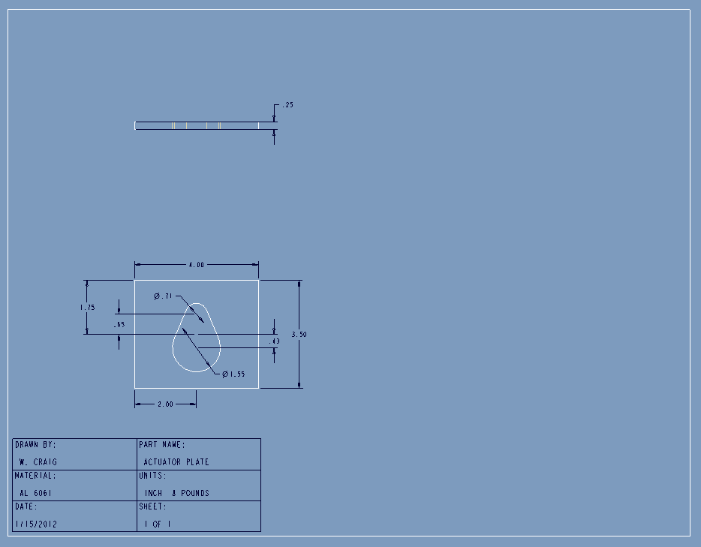

F2)

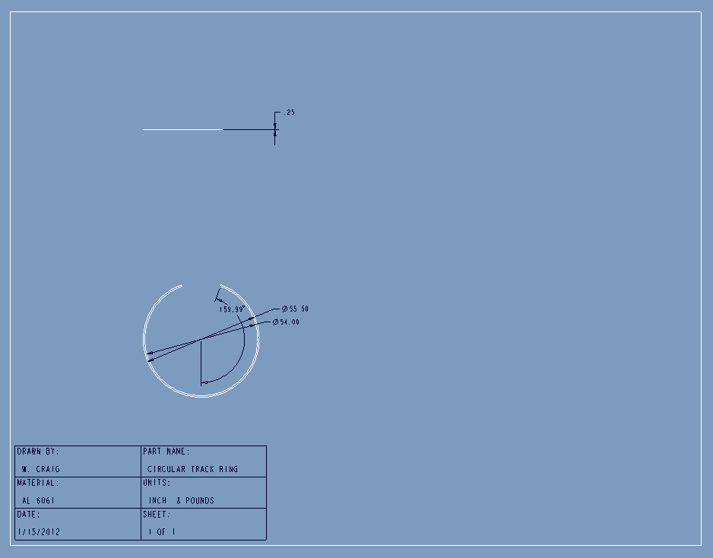

F3)

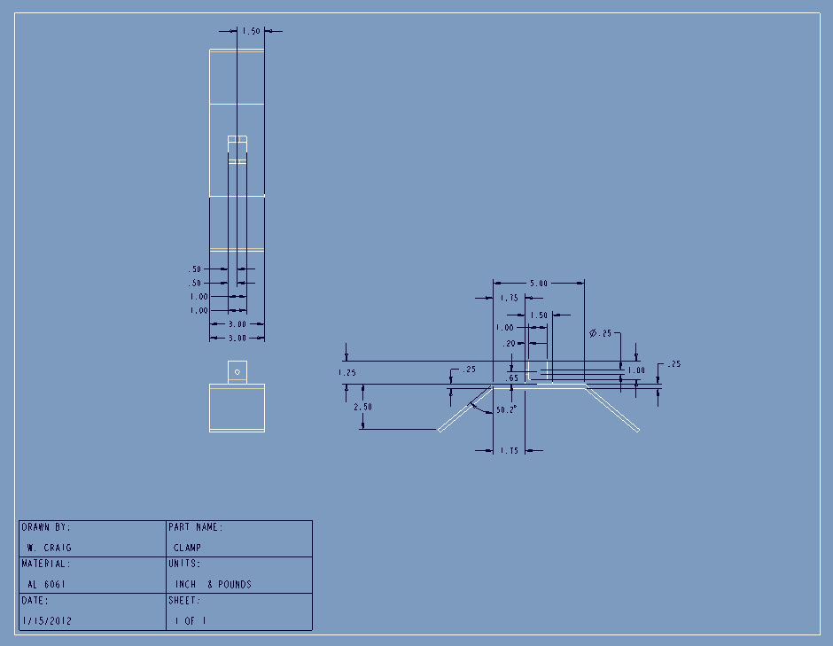

F4)

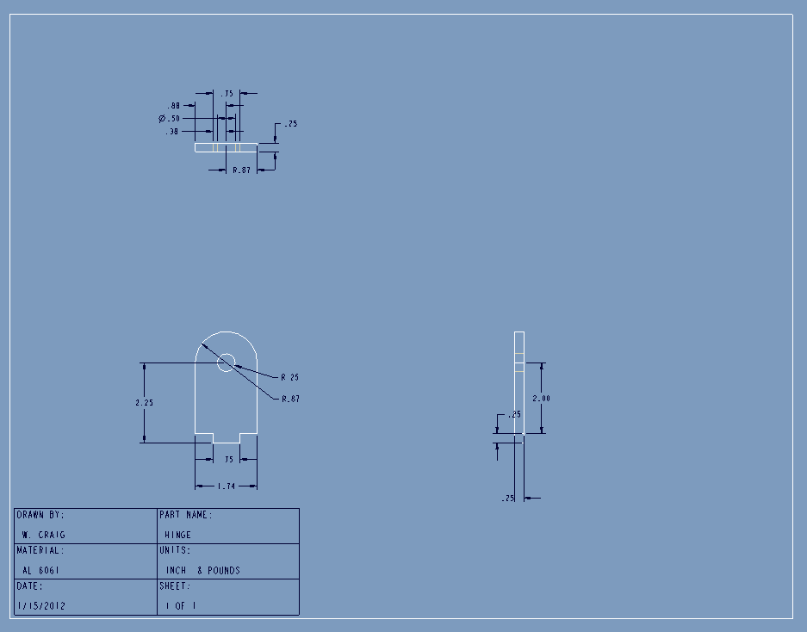

F5)

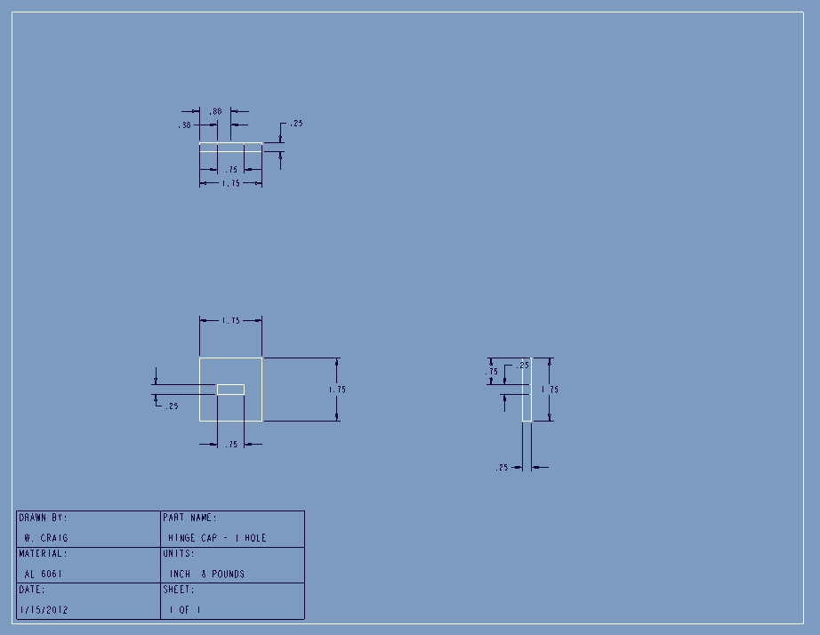

F6)

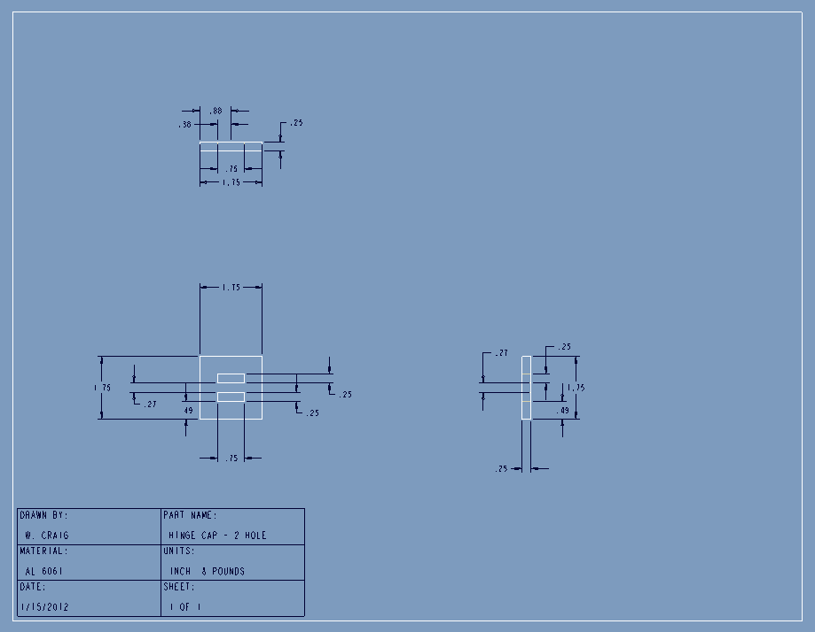

F7)

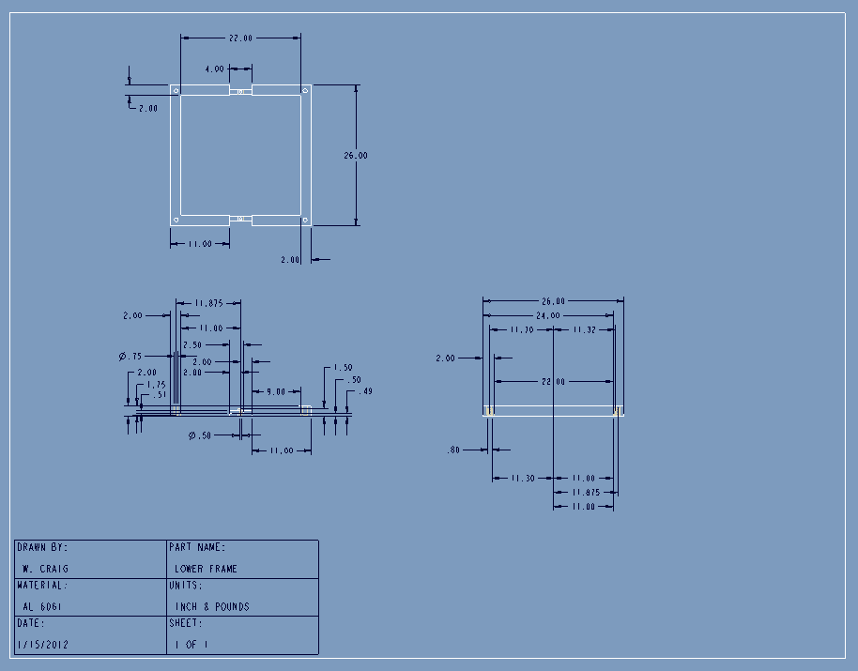

F8)

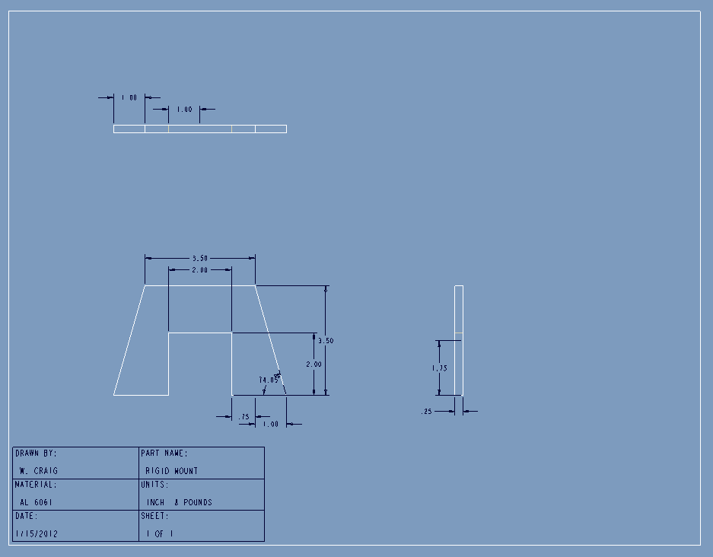

F9)

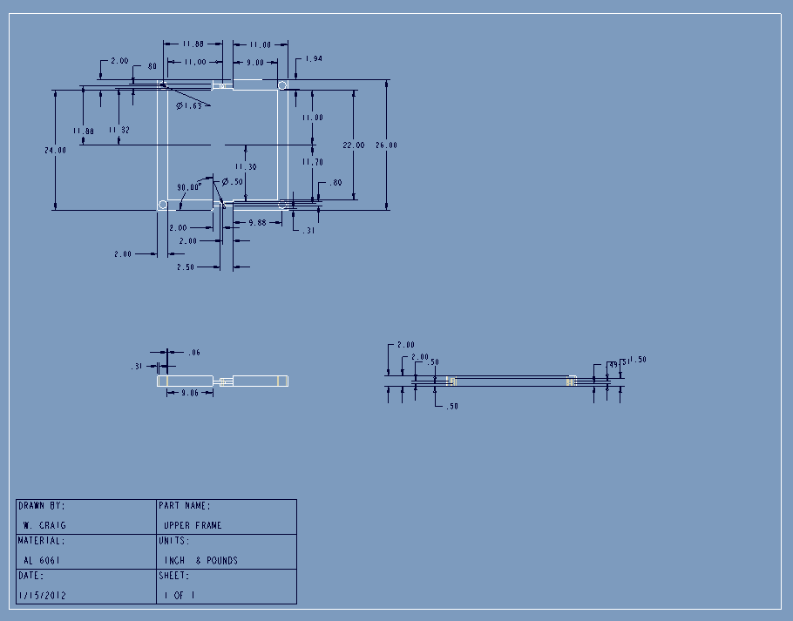

# References

“Crude Oil (petroleum) Monthly Price - US Dollars per Barrel.” Index Mundi. January 2012

< http://www.indexmundi.com/commodities/?commodity=crude-oil>

Davison, Craig. “Cattle costs rising, but local farmers still seeing profits.” The News and Advance. Media General Communications Holdings, LLC. 2012. February 29, 2012

<http://www2.newsadvance.com/business/2012/feb/29/cattle-costs-rising-local-farmers-still-seeing-pro-ar-1729011/>

“FAO Corporate Document Repository: Small-scale palm oil processing in Africa...” Food and Agriculture Organization of United Nations (FAO). 2012 <http://www.fao.org/DOCREP/005/Y4355E/y4355e03.htm#TopOfPage>

“Palm Kernel Oil Monthly Price - US Dollars per Metric Ton.” Index Mundi. January 2012 <http://www.indexmundi.com/commodities/?commodity=palm-kernel-oil>

“Palm oil Monthly Price - US Dollars per Metric Ton.” Index Mundi. January 2012 <http://www.indexmundi.com/commodities/?commodity=palm-oil&months=60>

Aberdeen Group. (2005). New Product Development: Profiting from Innovation.The New Product Development Business Value Research Series, Boston, MA.

“Palm Kernel Cake.” Alibaba.com. 2012

<http://www.alibaba.com/product-tp/120498560/Palm_Kernel_Cake.html>

# 

# Biographical Sketches

Obiechina Iruka Abakporo

I am a mechanical engineering major at FAMU/FSU College of Engineering in Tallahassee, FL. I plan on pursuing a graduate degree in Mechanical Engineering conducting PEM Fuel Cell research under the tutelage of Dr. Juan Ordonez upon graduation. I have worked as a TA under Dr. Hruda and Dr. M. Moore as well as a lab manager of the Robotics Lab for Dr. C. Moore. I believe I am a living example of all things are possible. If I was asked a couple of years ago if I would be working with some of my professors based off of my academic performance and even considering the pursuit of a graduate degree…I would have laughed. I thank God, my mother (who is my greatest inspiration), my family, friends, and all of the countless people who have positively influenced my life, believed, and even depended/still depend on me to be the best I can. Without that motivation, I probably wouldn’t have cared to even try, but rather settle with simply getting by. Lastly, I wanted to thank my senior design teammates for the contributions that they have made towards the success of this project and the contributions that they have made to better me personally, especially my friend William Craig. “Be who you are and say what you feel because those who mind don’t matter and those who matter don’t mind.”

William Craig

I am currently a senior pursuing my B.S. in Mechanical Engineering at the FSU-FAMU College of Engineering. I was born, raised, and attended schooling in Ft. Lauderdale, Florida. When not doing schoolwork I enjoy being outdoors, whether it be fishing, diving, or hanging out at the beach. I have a Chocolate Labrador named Moose that usually accompanies me on my outdoor adventures. My favorite courses throughout my undergraduate career were Propulsion Systems and Mobile Robotics. After graduation, I plan on finding an interesting and challenging job that will require the use of the tools I have acquired and allow me to grow as an engineer.

Christopher Xavier Smith

I am a senior mechanical engineering student at the FSU/FAMU College of Engineering. My current focus is to find a job in the power generation field and the dream job would to be working for a small solar startup. I hope to be moving out west with my girlfriend as soon as I graduate and make a new life out there. I have had a little twelve pound dog named scrappy for the past two years and I think she is the best dog possible. Hobbies that I enjoy include volleyball, camping, snowboarding, and whatever video game currently has my interest. School has been my life the past few years and I am both nervous and excited to be moving on to something new.

Bill Carpenter

I am in the last semester of my senior year at the FSU-FAMU College of Engineering. After I attain my B.S. in Industrial Engineering I plan on pursuing a law degree. I was born in Texas, then moved to Michigan, and then ended up in Florida. I attended high school at North Florida Christian School here in Tallahassee, where I was part of State Championship baseball team. I also played collegiate baseball for Rollins College and Northwest Florida State University. When I am not working on my scholastic studies, I participate in mixed martial arts. The sport has taken me all over the country and given me countless experiences that I am very grateful to have had.

Sarah Trayner

From Tampa, Fl, I am graduating in April 2012 with a B.S. in Industrial Engineering with Honors Cum Laude at the FSU-FAMU College of Engineering. Recently, I have completed my Honor’s Thesis and have decided to pursue a Master’s degree in Materials Science. I have always been inspired and motivated by family and friends to reach my goals and pursue my dreams. I have come to a realization that engineering has always been the solution to my insatiable appetite for learning. Because of this, I believe that, by obtaining an engineering degree, I have indirectly signed a contract for lifelong learning. Keeping this in mind, obtaining an engineering degree is just the beginning.

Juan Antonio Rojas

I was born and raised in Panama, where I also completed my first 60 credits of college at the FSU-Panama campus. I am currently pursuing a bachelor’s degree in Industrial Engineering, which I will obtain in Summer 2012. After completing my bachelor’s degree I plan on going back to Panama, to work for at least three years. After gaining work experience, eventually I want to start my master’s degree in Europe. Even though I am studying industrial engineering I want to pursue a career in energy efficiency and with this, start a business that I am passionate about. I have traveled to several countries where I realized that being able to speak multiple languages is an advantage. Because of this, I want to become fluent in Italian, learn French and, if possible, another languages. My hobbies include playing soccer, longboarding, and practicing percussion and guitar.